

Dynamics 365 Banking Accelerator

Workflow Walkthrough

**Published**:

**Version**: 1.0

Table of Contents

Introduction 3

Personas 3

Retail 4

Retail Daily Start 4

New Customer 5

New KYC 8

New Prospects 10

New Mortgage 16

New Certificate of Deposit 19

Commercial 22

Commercial Daily Start 22

Applying for a New Loan 23

Business Checking Account 29

# Introduction

The Microsoft Dynamics 365 Banking Accelerator is a solution released to sit on top of an existing Dynamics instance and assist with day to day banking operations. The solution has been split into both Retail and Commercial banking and can be implemented with one or both. The Accelerator contains installable solutions that include standard entity attribute extensions, new banking entities, pre-built dashboards, workflows, sample data as well as other tools to help customers and partners build and deploy new banking solutions.

This documentation provides a walkthrough of the key dashboards and flows with both the retail and commercial solutions.

## Personas

The walkthrough document was created with the following Personas in mind:

1. Loan Officer
   1. The Loan Officer will use the system to facilitate loans on both the Retail and Commercial side. They will use the both loan application flows to standardize applications.
2. Risk Officer
   1. The Risk Manager will use the system to work with the People and Companies who may be becoming higher risk customers.
3. Relationship Manager
   1. The Relationship Manager will work with People and Companies to build stronger relationships and help build out a full Customer 360 view.
4. Banking Customer
   1. The Banking Customer can be either a Person or Company who works with the bank.
5. Banking Analyst
   1. The Banking Analyst will use both the dashboards and analytics to help the bank and customers make effective decisions.

# Retail

## Retail Daily Start

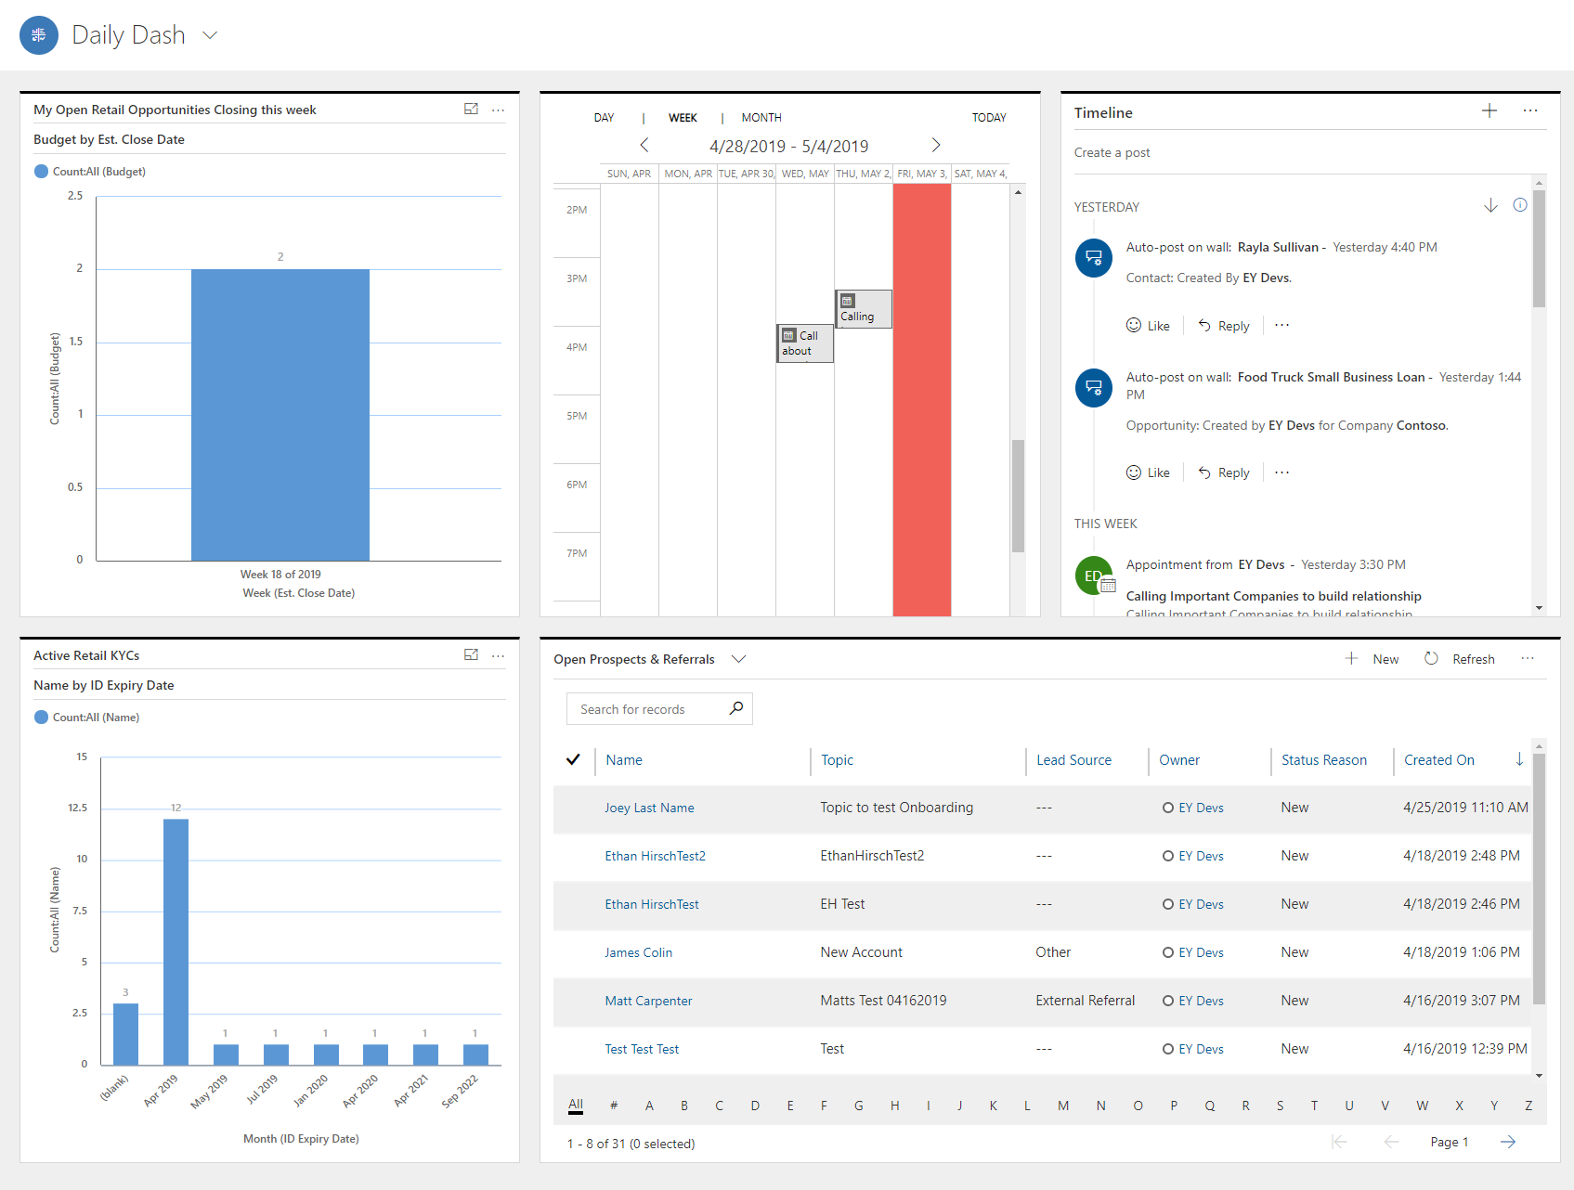

The Retail Relationship Manager sits down and logs into their computer. They login to dynamics to get a high-level overview of their day, along with important charts like any Opportunities scheduled to close this week and KYCs with Expiring ID Dates by Month. The Manager will also be able to see a timeline of their upcoming events and tasks along with all their Open Prospects and Referrals.

## New Customer

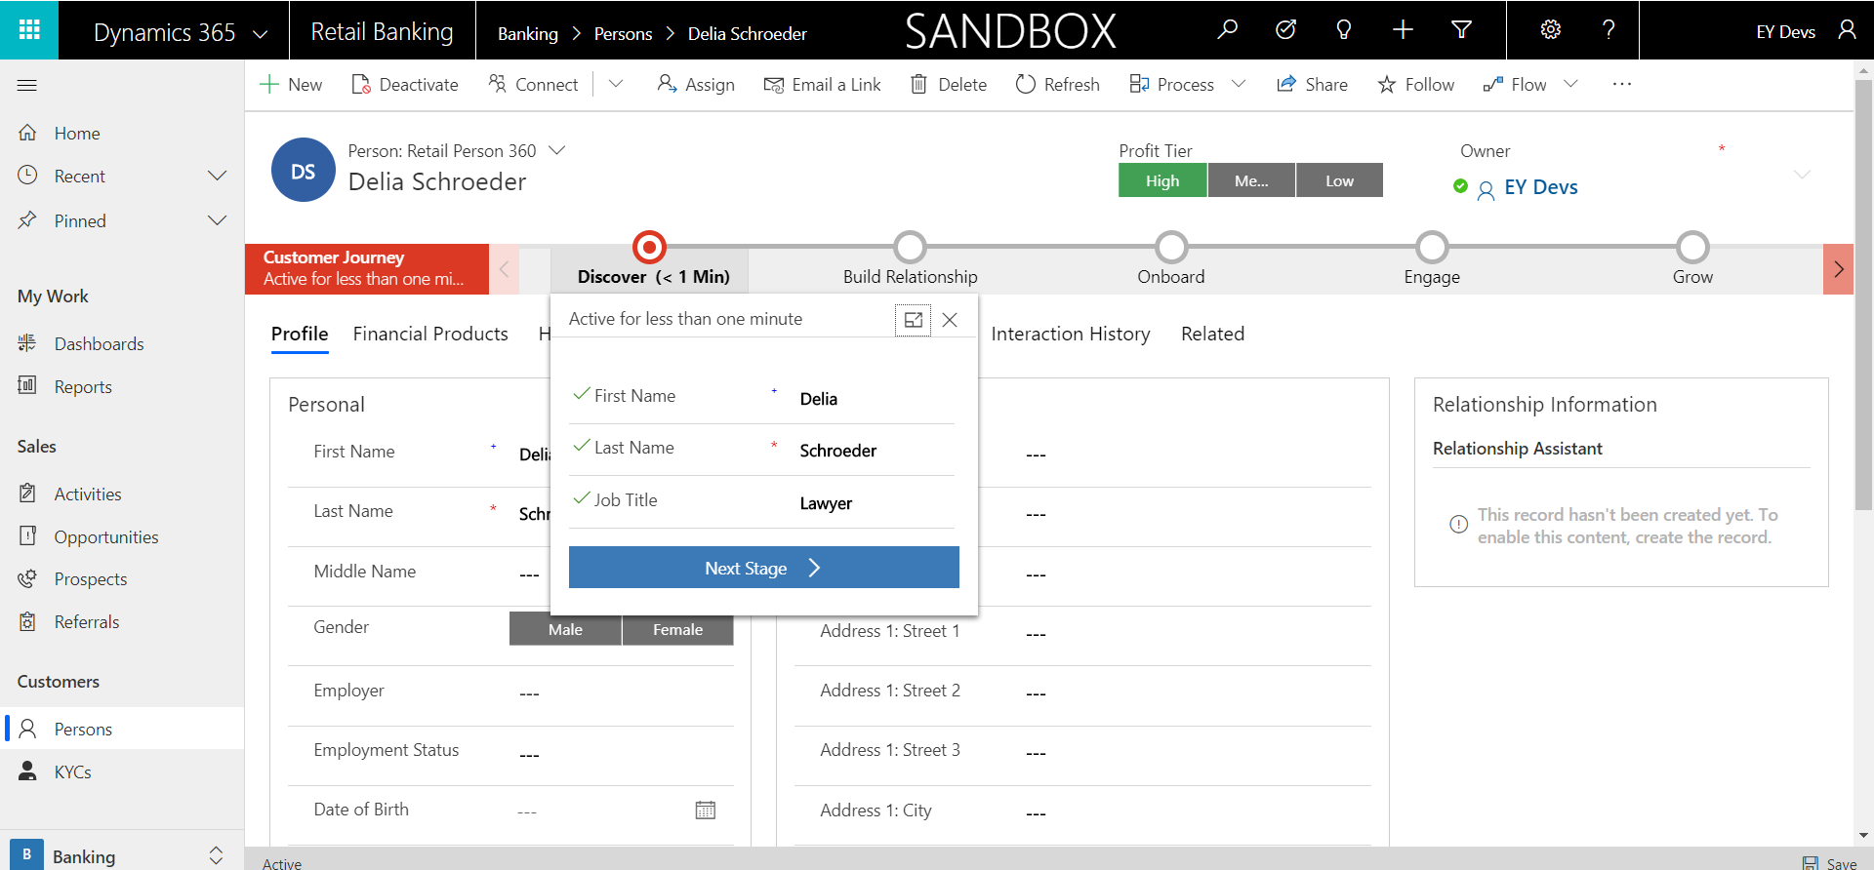

1. The Customer Journey begins on the specific Person record. As a Relationship Manager you will began by validating the basic contact information and adding a Job Title if there wasn’t one on the initial Person creation.

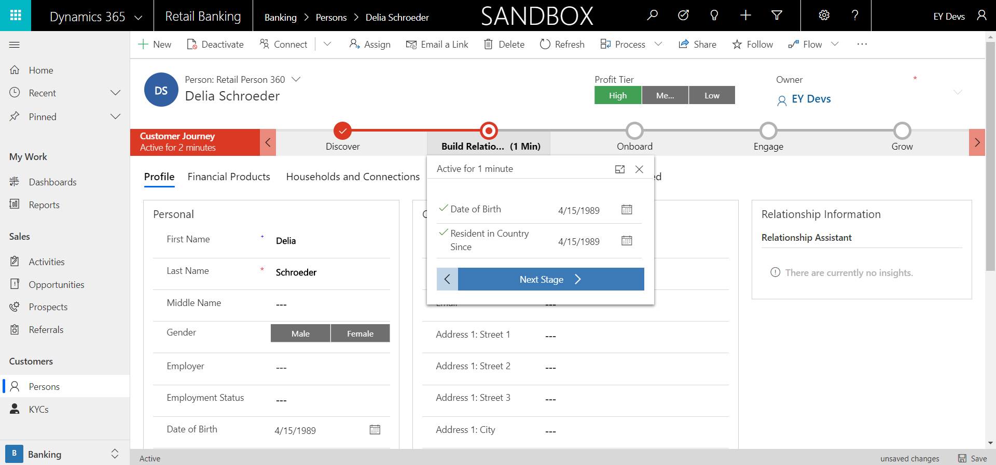

1. Next you should ask the customer for their Date of Birth along with how long they’ve been in the country. If already entered, these could also be used as verification tools.

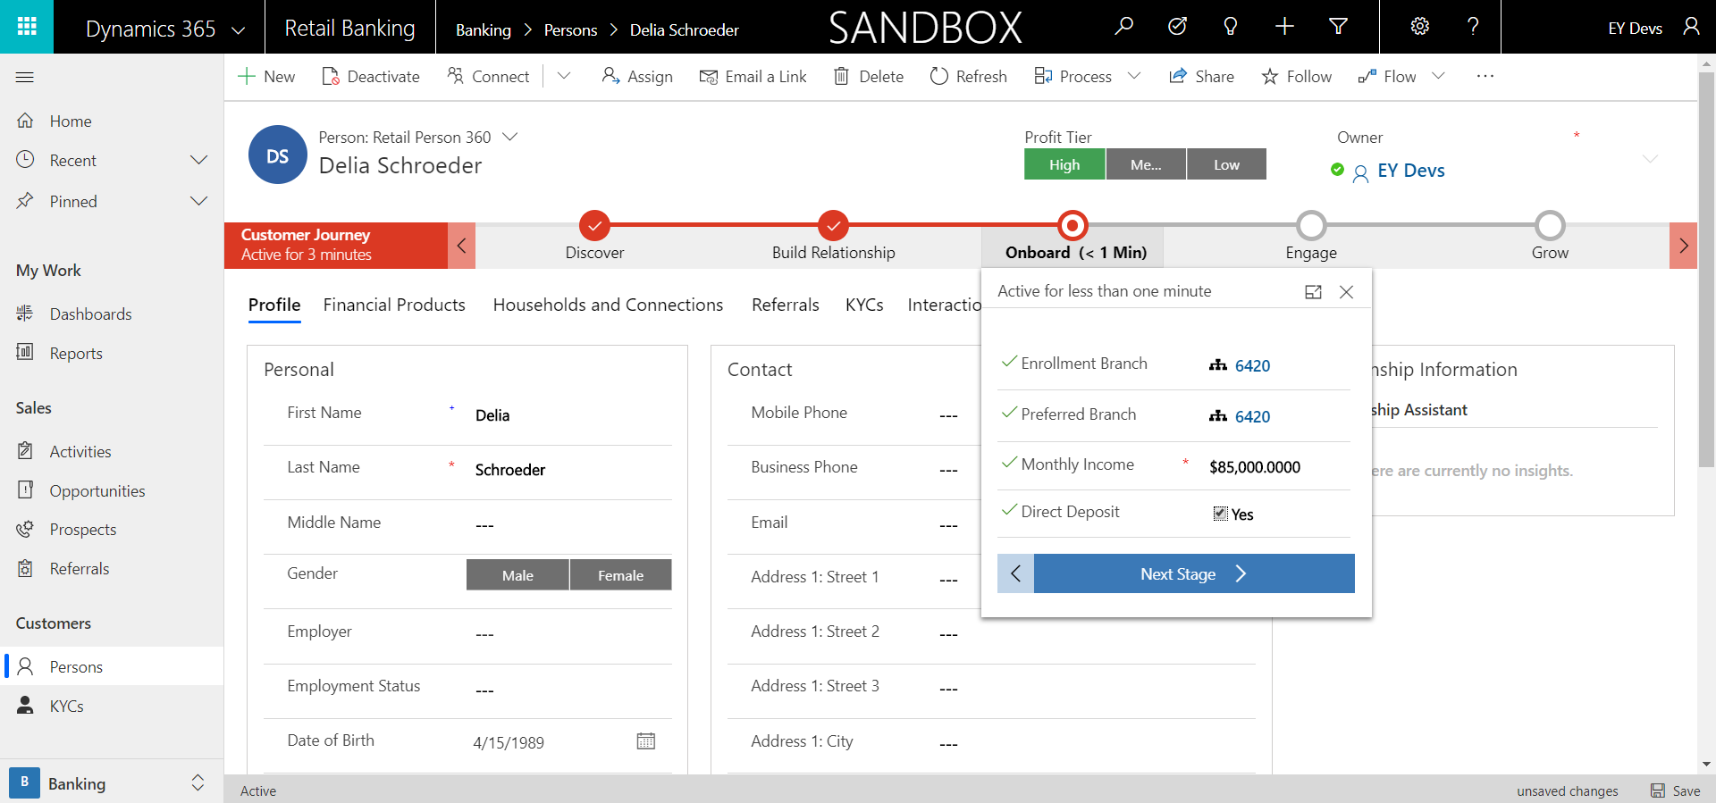

1. The next step you will want to fill out some Bank specific information about the customer. These include the Enrollment Branch, Preferred Branch, Monthly Income and if the customer is set up for Direct Deposit.

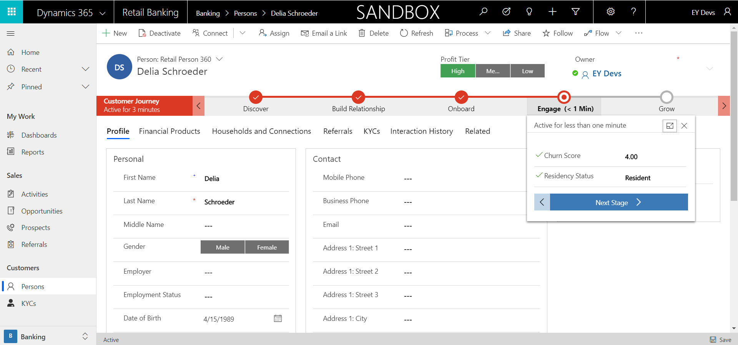

1. During the Engage step, you’re going to enter the Person’s churn score along with their Residency Status.

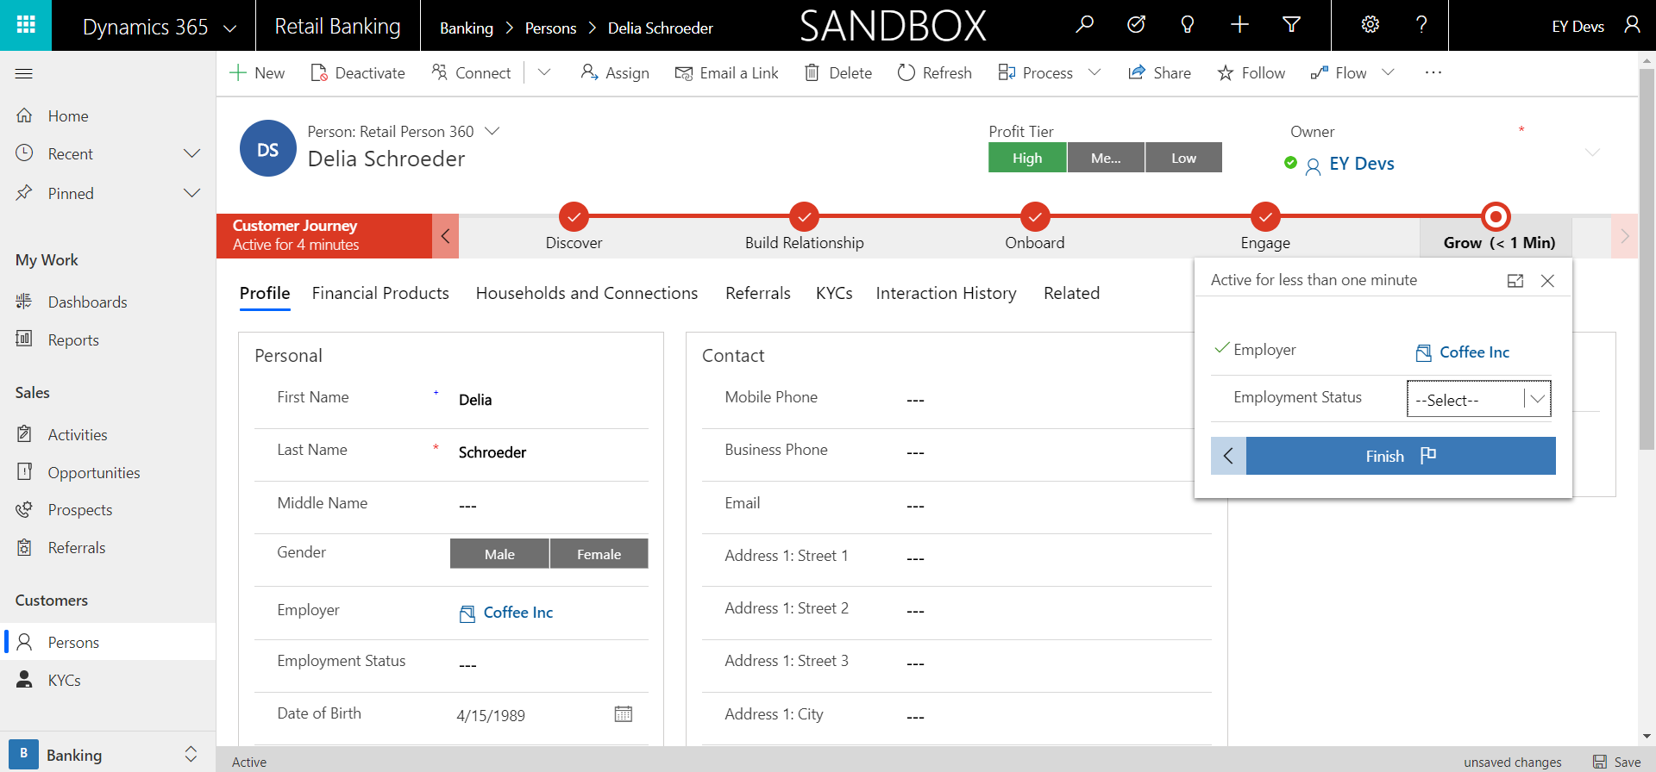

1. The final step of the Customer Journey is adding in the customer’s Employer along with the Employment status. From here, you can finish the Customer Journey business process flow, and you can begin using the Customer 360 form.

## New KYC

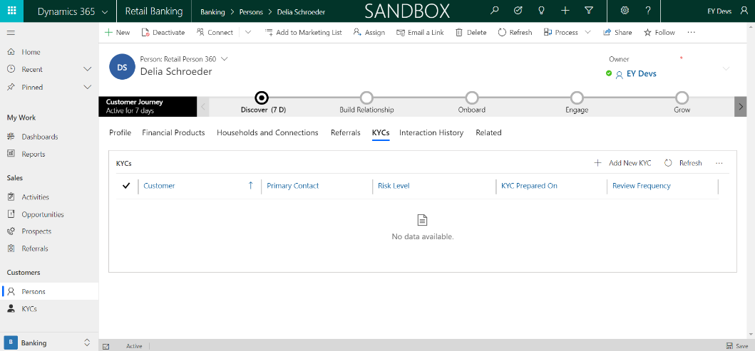

1. When a customer either has older or no KYCs at all, a Relationship Manager will need to create them. They can find the KYCs associated to a Person on their Person 360 form under the KYCs tab. On the tab you can see the “+ Add New KYC” button.

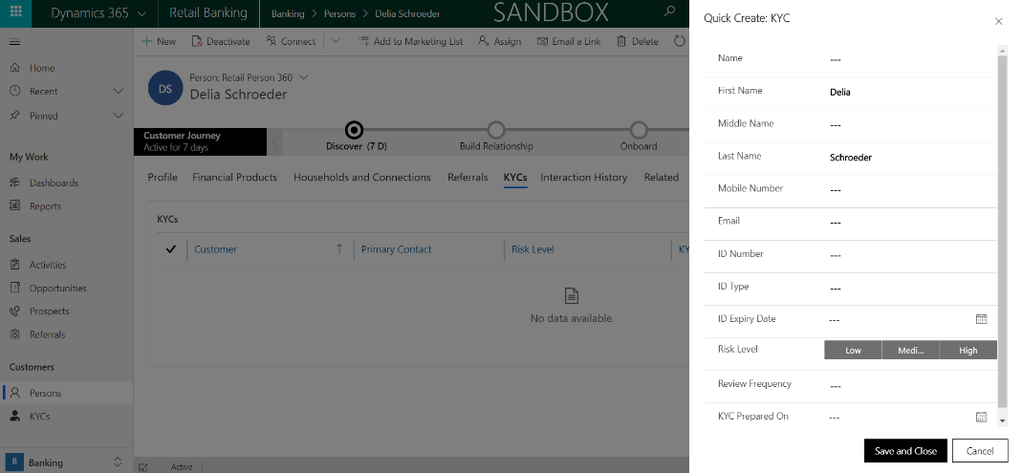

1. After clicking the Add New KYC button, a quick create form appears on the screen where you can enter in much of the information needed by the KYC. They can always go to the KYC and add information.

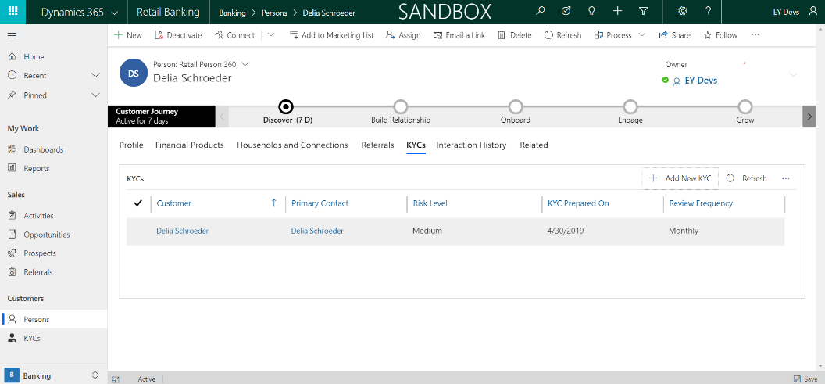

1. After choosing to save and close, you can see the KYC you created appear in the sub grid on the Person form. From here you can choose to click into the KYC and edit any of the information you need to. Based on the Review Frequency you can come back and add new KYCs.

## New Prospects

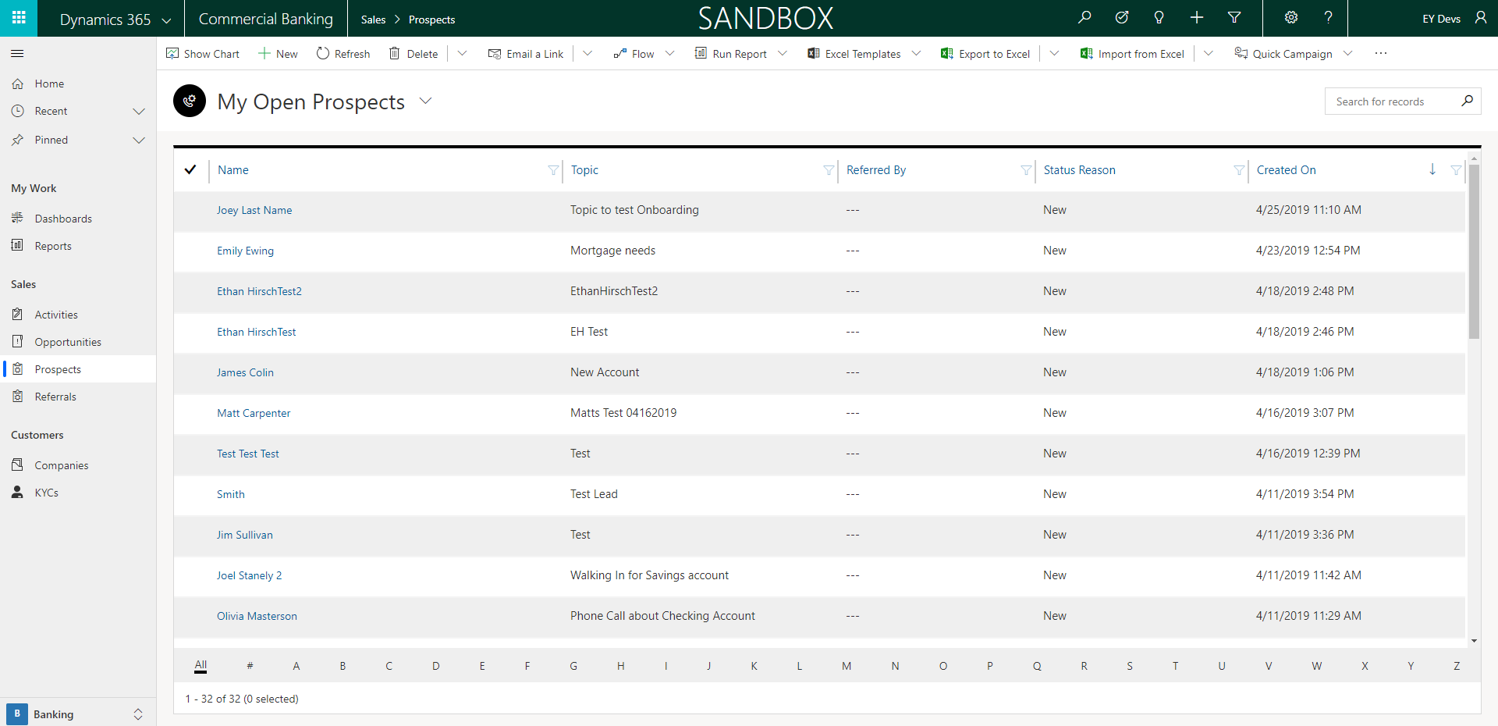

1. If your role has access to Prospects, you will need to create them to add new customers to the system. When Creating a new Prospect, you start on the Prospect page and click “+ New” in the top left.

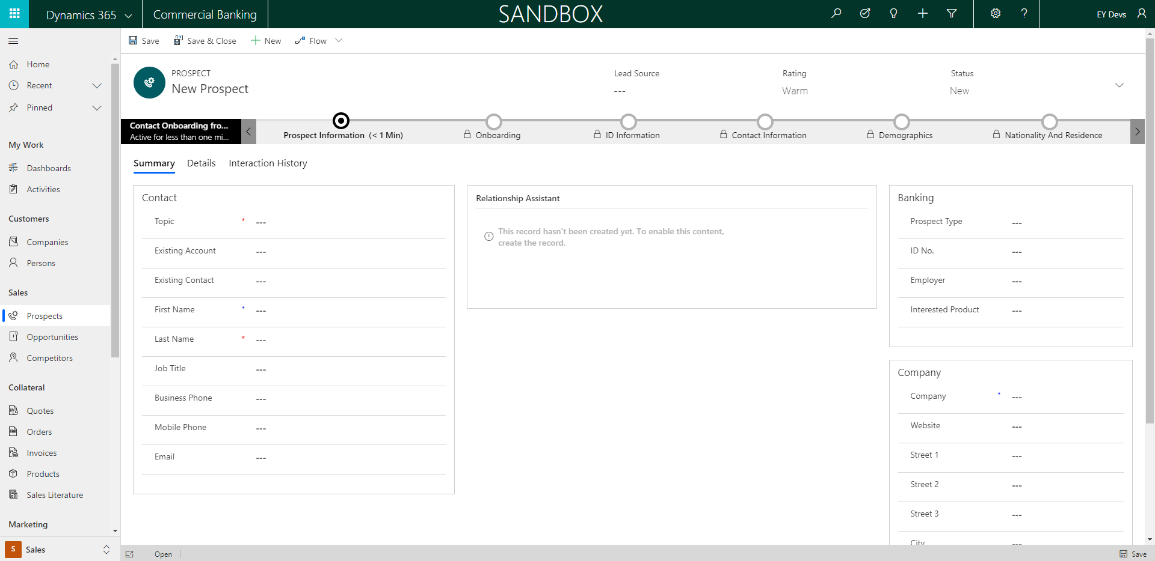

1. From there you are taken to the new Prospect page where you can add the required fields Topic, First Name and Last Name then save the record to start the Onboarding process.

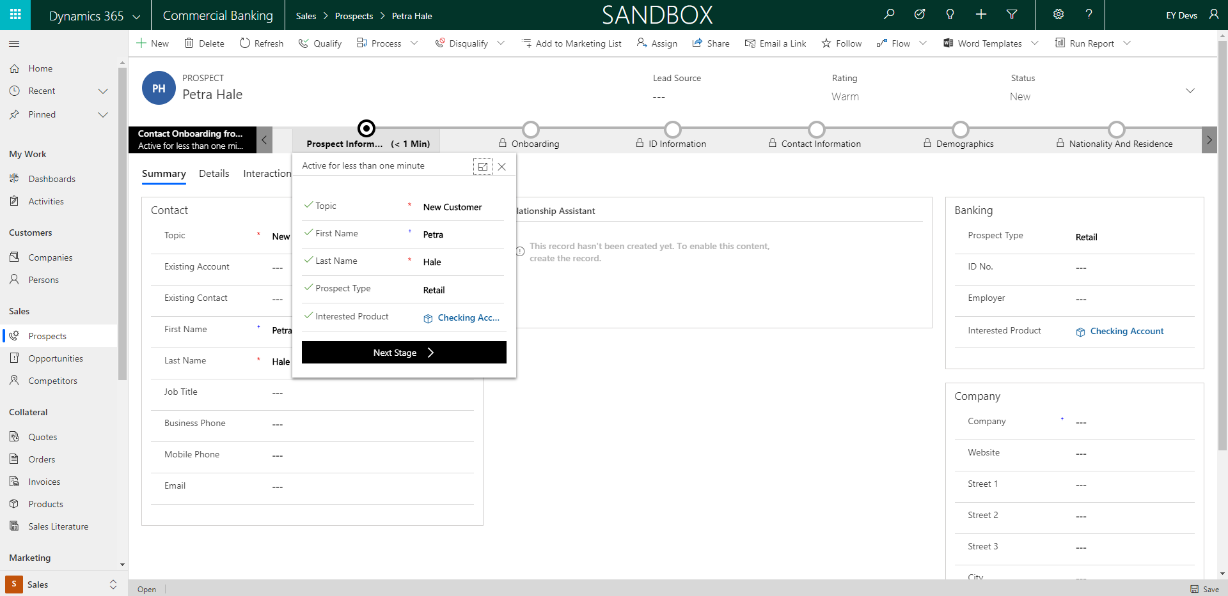

1. In the first stage you will have the potential customer provide information such as what type of Prospect it is and the Product the new customer is interested in.

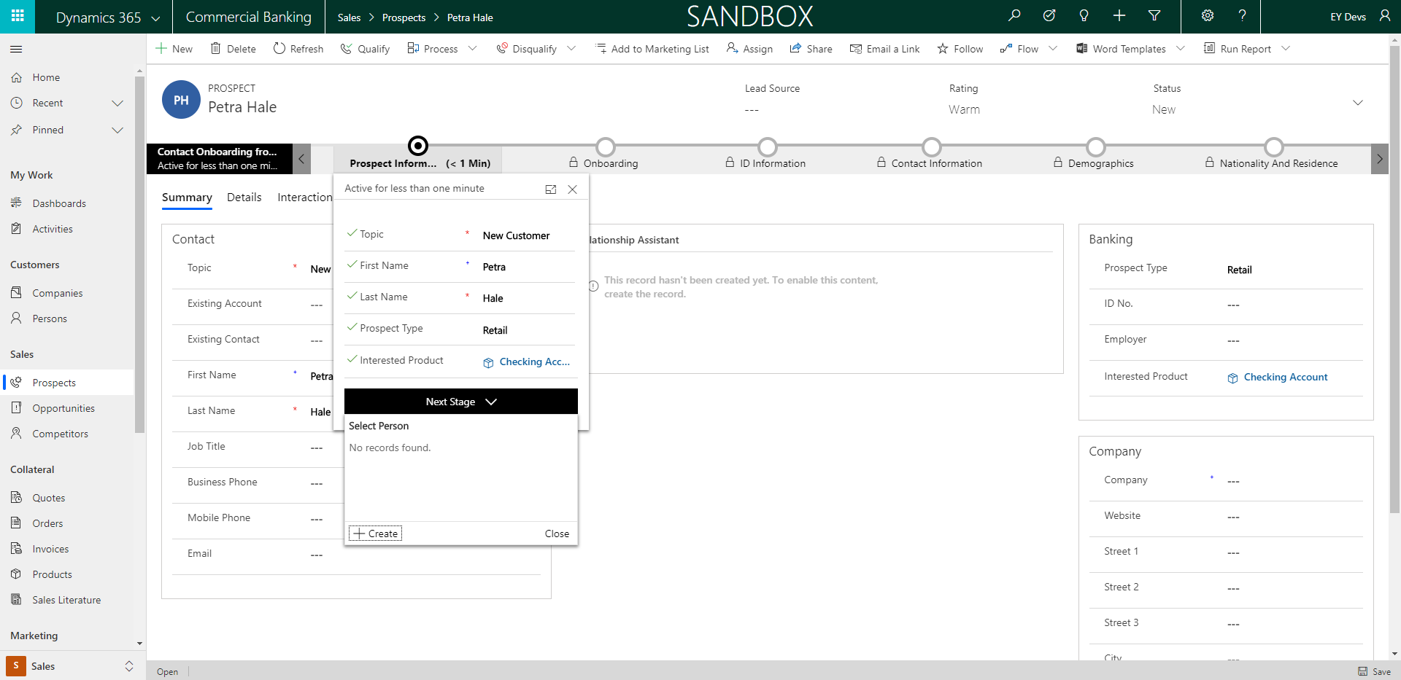

1. In the next stage, you will create a new Person record if the customer doesn’t exist in the system. If the customer does exist, then you can choose the name from the drop down.

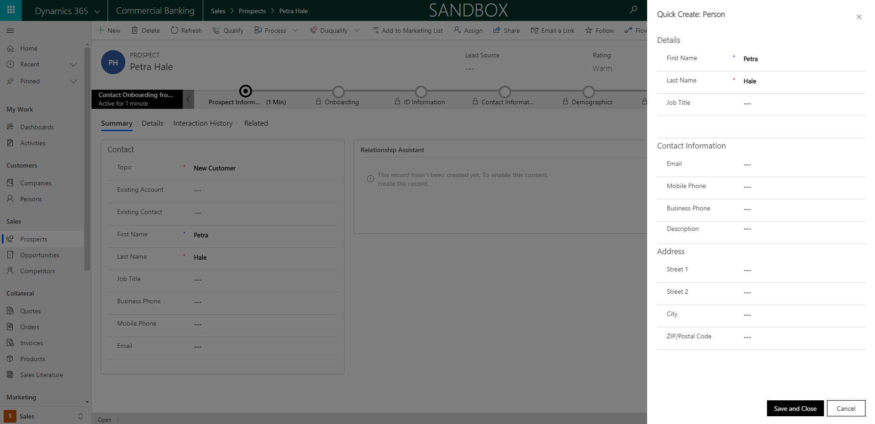

1. Adding a new Person from the Prospect page will bring up a new form where you can gather other high level information about new Person coming into the bank.

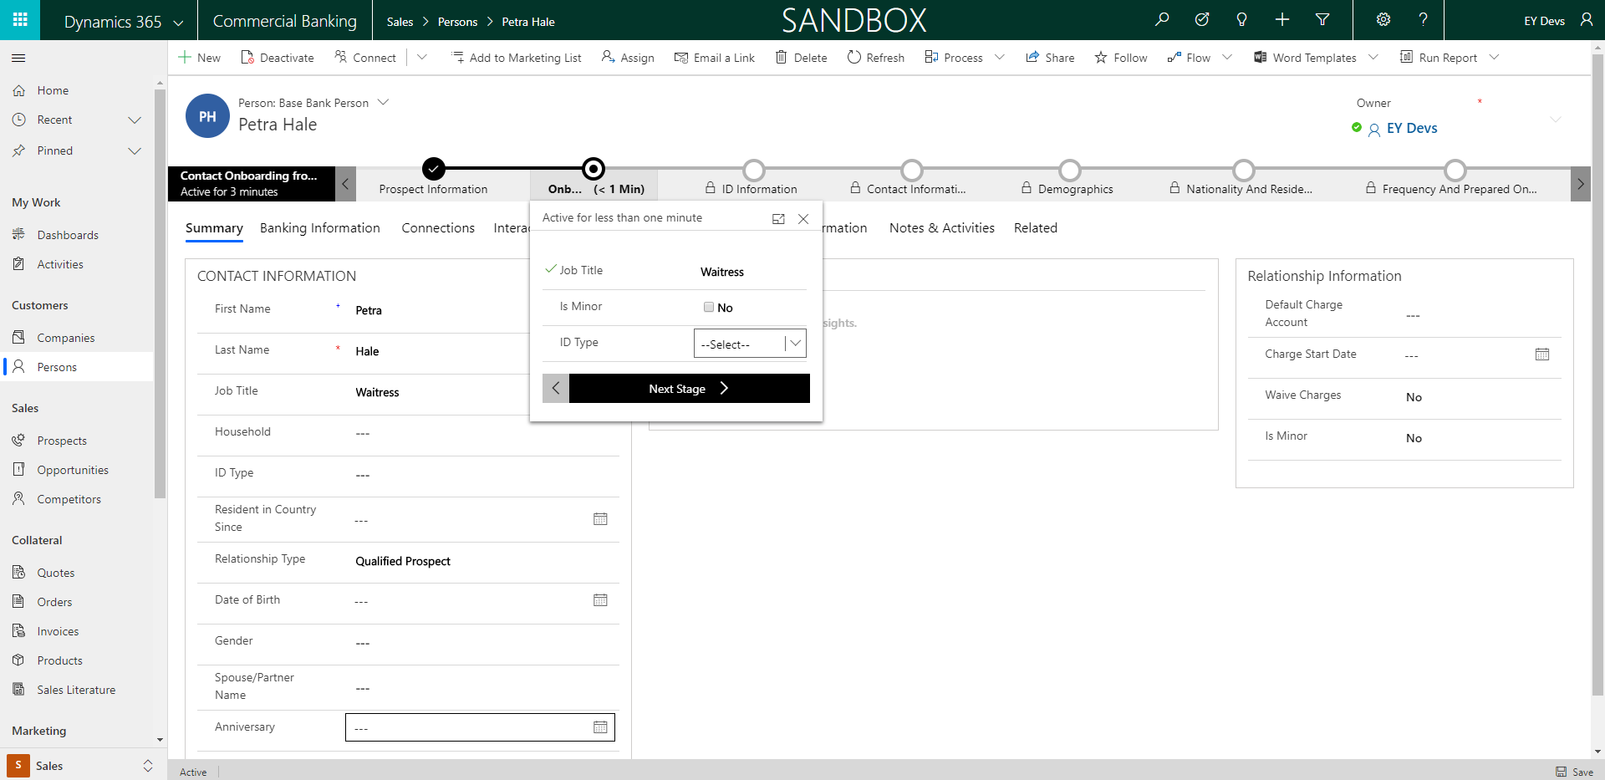

1. The next steps will be gathering information from the Person that is required needed by the Person 360 form. Onboarding requires Job Title, if they are a minor, and their ID Type.

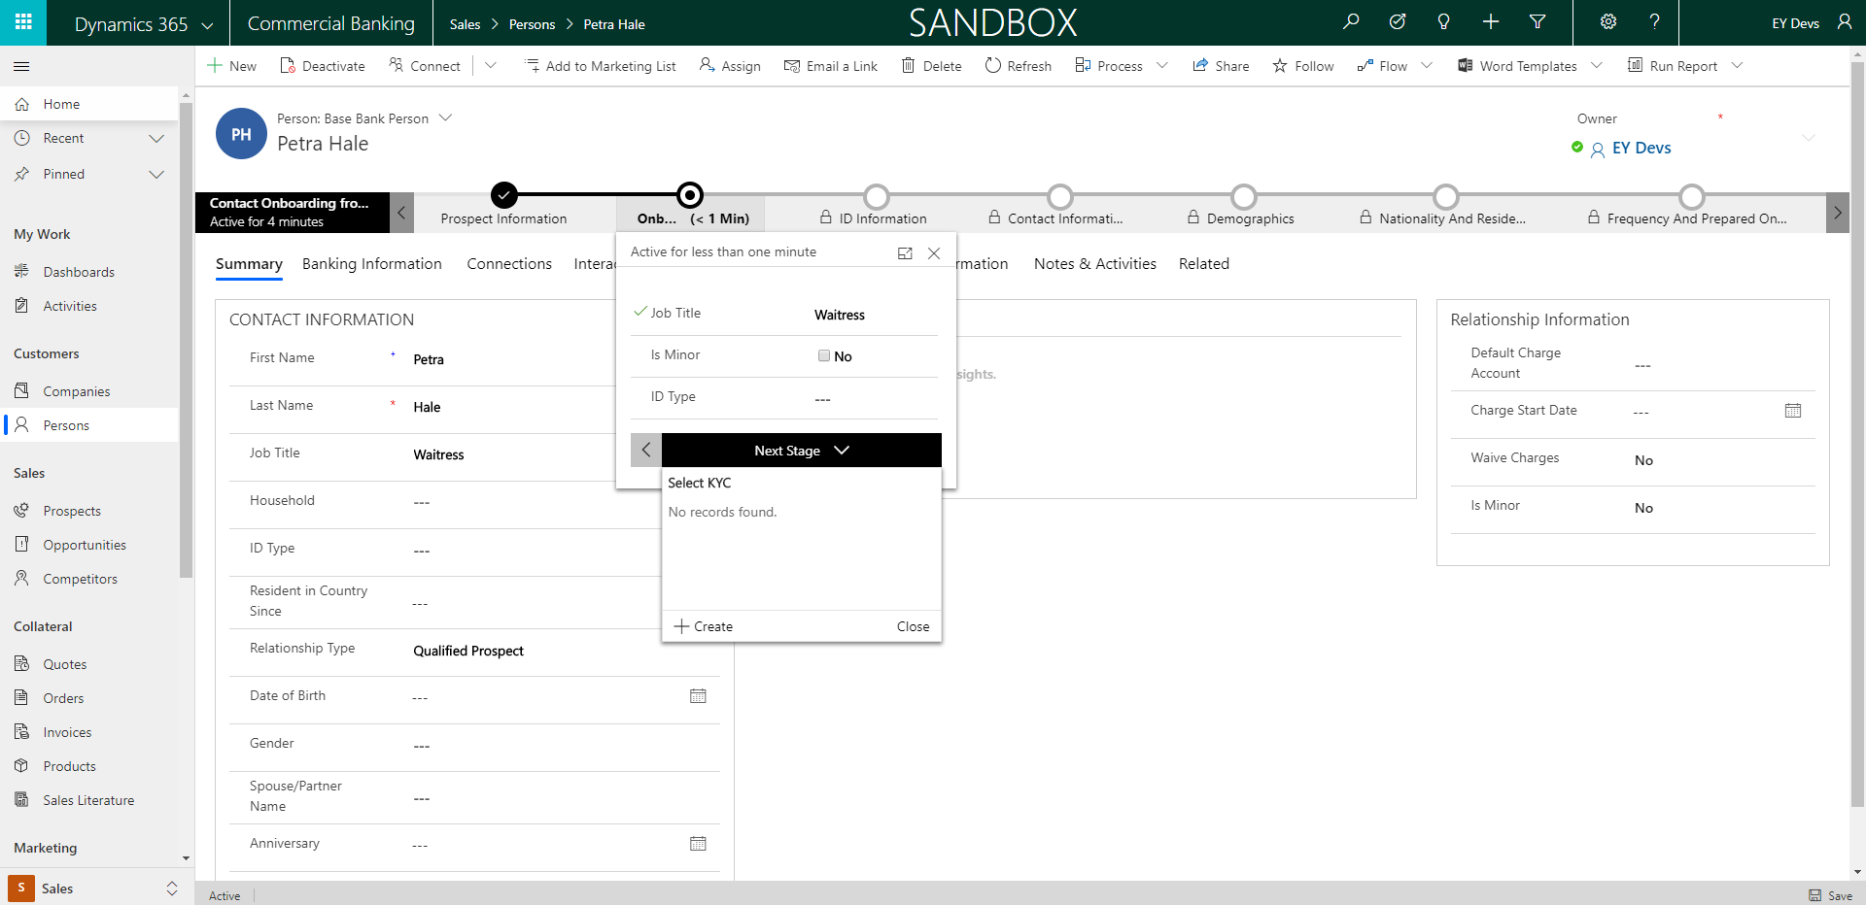

1. After entering in the initial Onboarding information, you will create the Person’s first KYC in order to gather some risk assessment information about them.

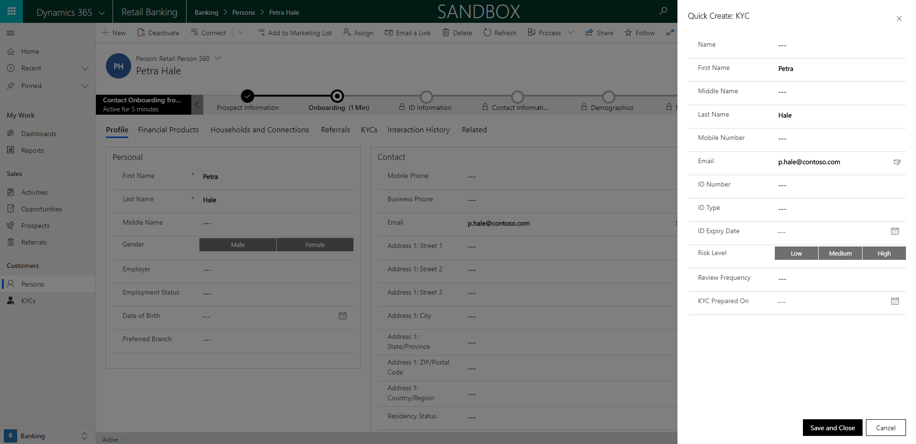

1. You will see a new form appears on the screen where you can enter in much of the information needed by the KYC. If any information needs to be added or updated, you can find the KYCs on the Person 360 record.

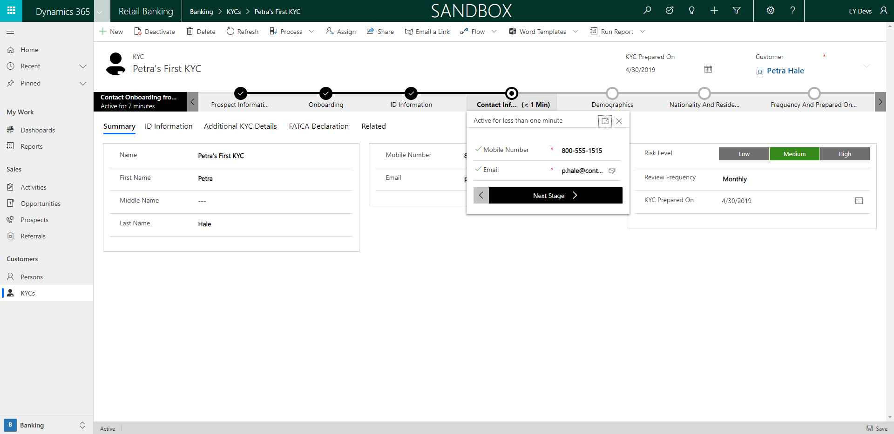

1. After creating the KYC, you will have to make sure that the Person has a mobile number and an email associated.

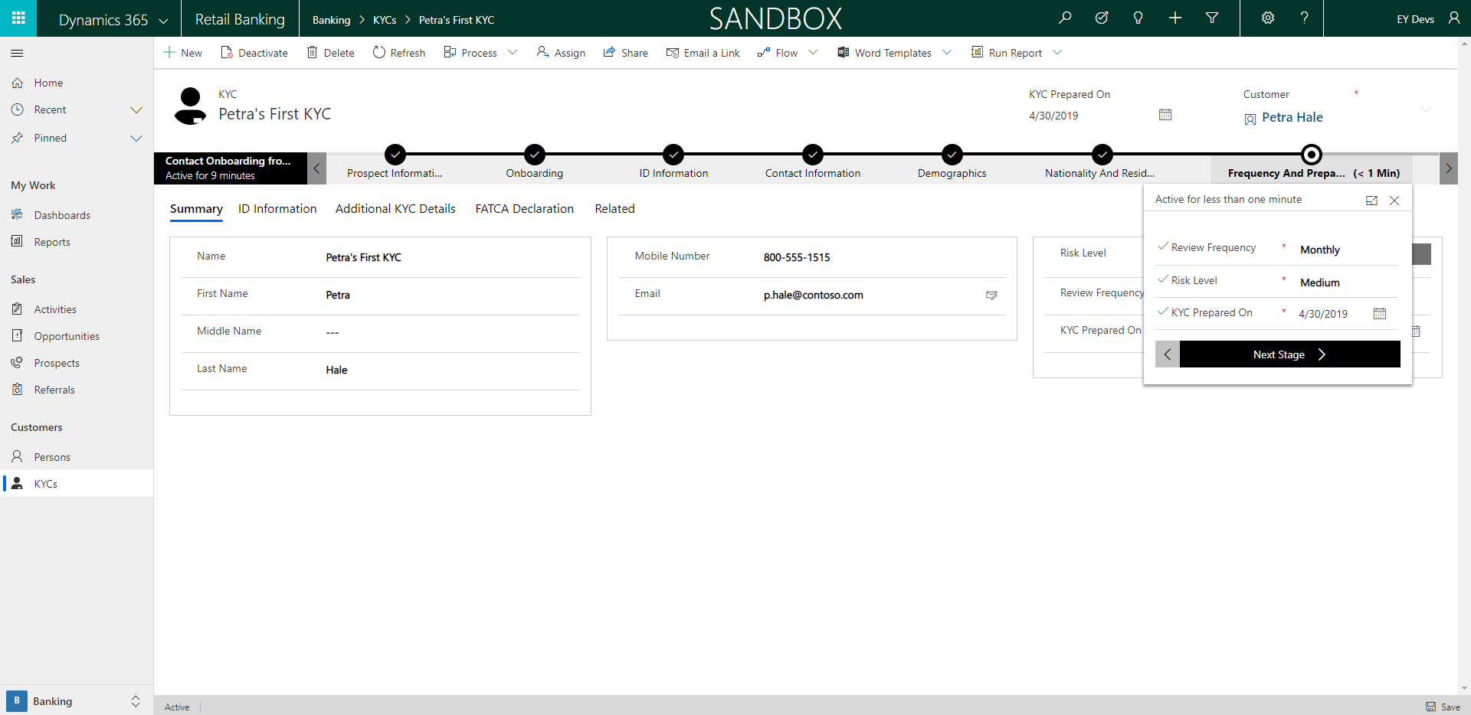

1. After entering the Demographic information and the nationality and residency, you’ll update the Review Frequency, Risk Level, and when the KYC was prepared on. This information will be used to determine if the Person is a good avenue for new opportunities.

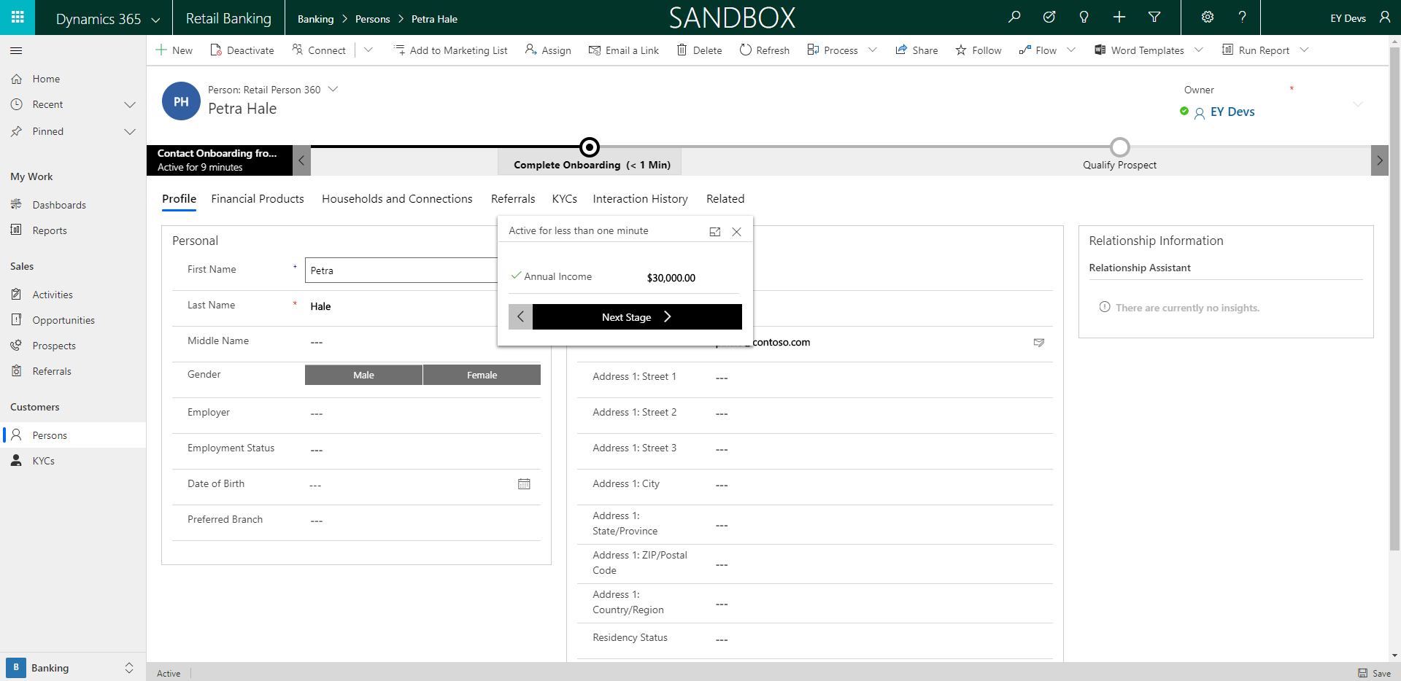

1. When you come back to the person form, you will need to add the person’s annual income. After their income is added, you can move back to the prospect form.

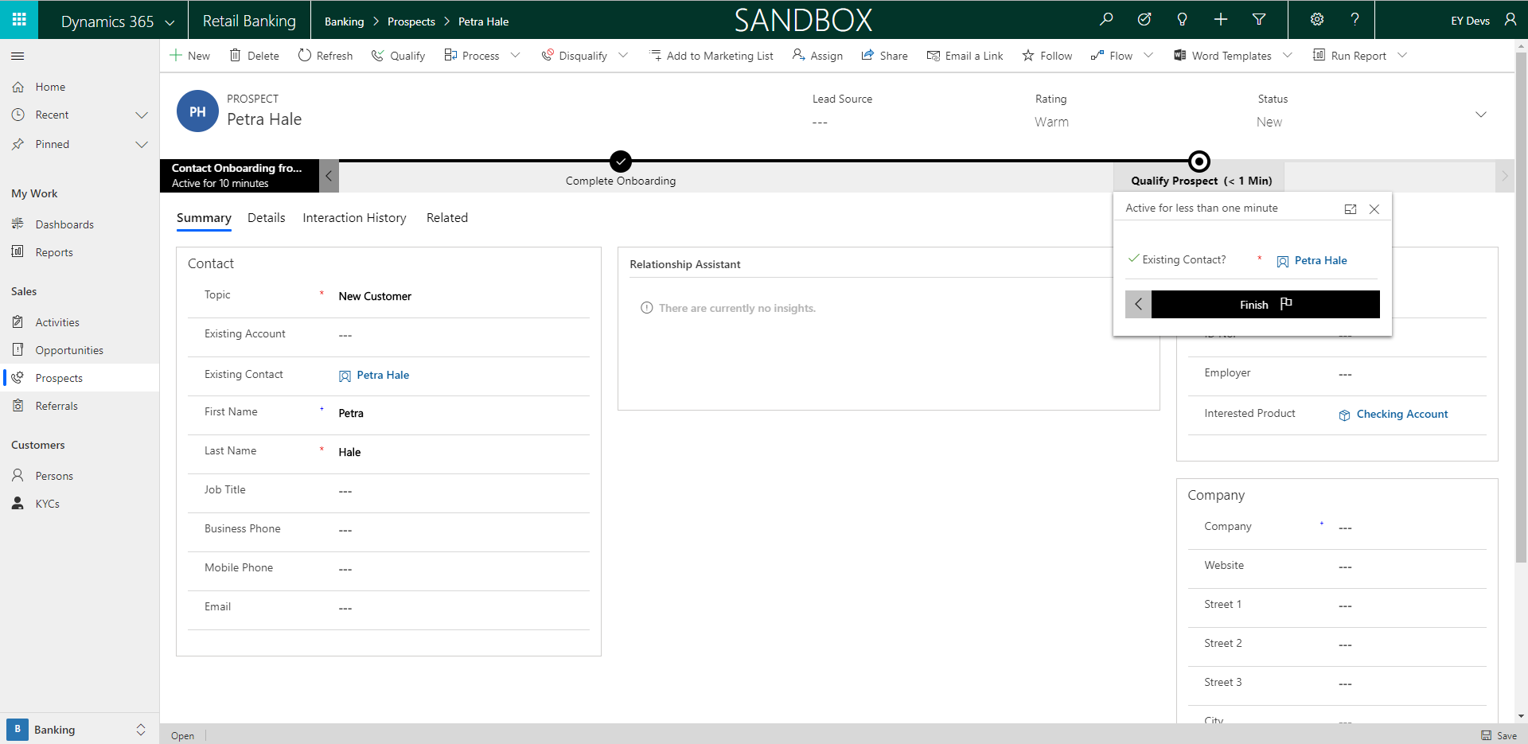

1. On the prospect page, you will then need to finish the business process flow, and qualify the prospect to make it an opportunity. Turning the prospect into an opportunity will help when we are applying the Person to for a loan or any other financial products. The qualify button is the fourth button in the ribbon.

## New Mortgage

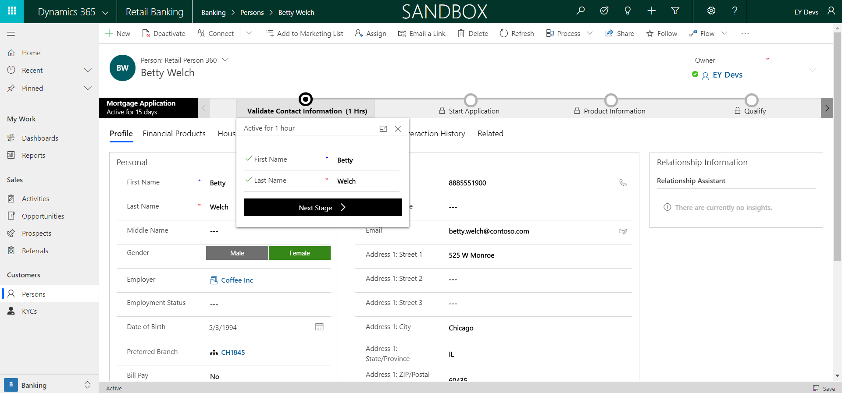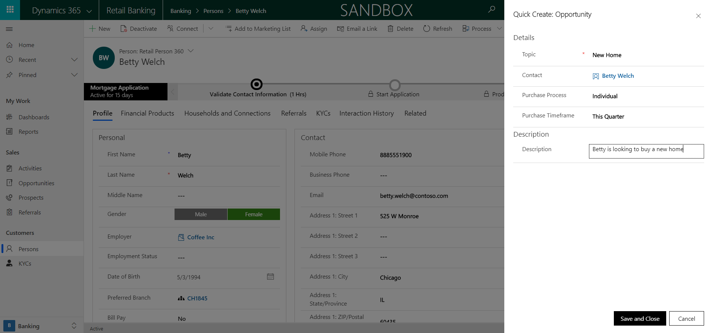

1. When creating a new mortgage, the Loan Officer will begin by checking the contact information and validating it with the Person applying for the loan. If the opportunity has been created by qualifying a prospect, then you can choose it from the drop down when clicking Next Stage.
   1. If the opportunity has not been created yet, click the “+New” button and a form will appear to enter in high level opportunity information.

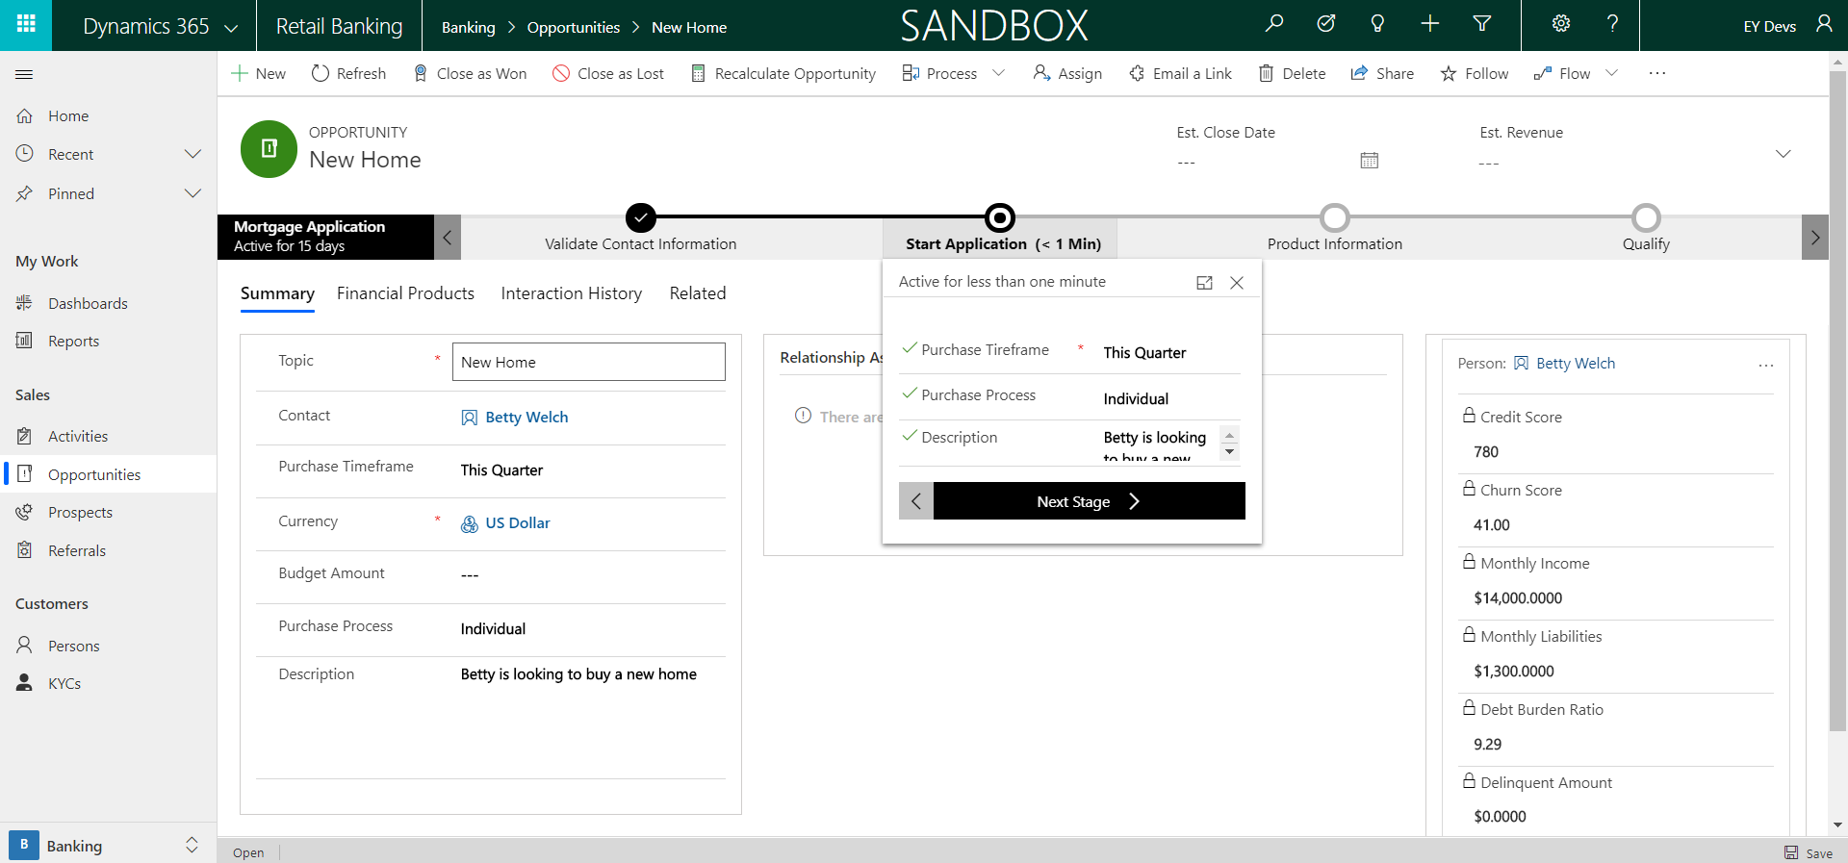

1. Saving the opportunity will take you to the next stage where you will start the application. The information will carry over and after verifying, you can move on to the product information.

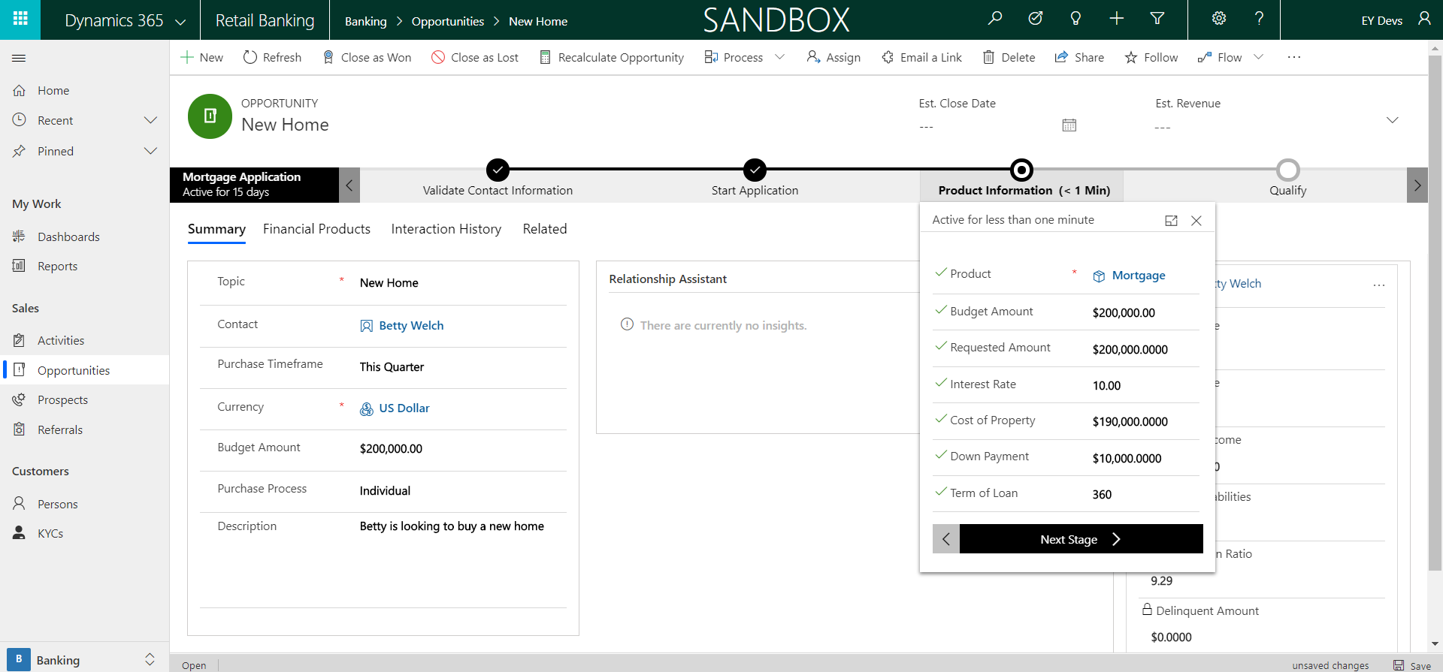

1. The next step in the flow is used to gather product information. This is going to be where the bulk of the loan information is entered or reviewed. This includes adding the Product, budget amount, requested amount, interest rate, and the cost of property.

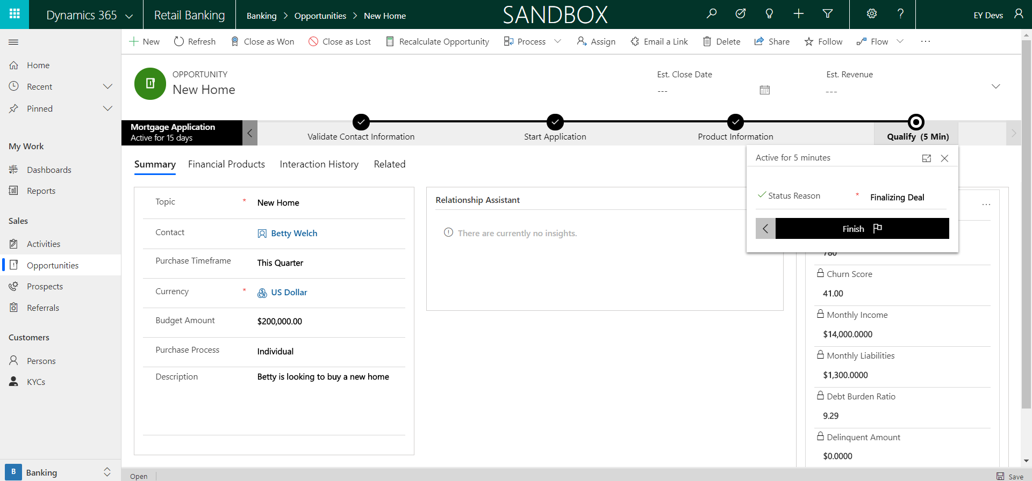

1. The last step in the application process is closing the opportunity. From here we finish the business process flow, set the status reason to finalizing deal, and close the opportunity as either won or lost. If Won, you can create a financial product of a mortgage for the customer.

## New Certificate of Deposit

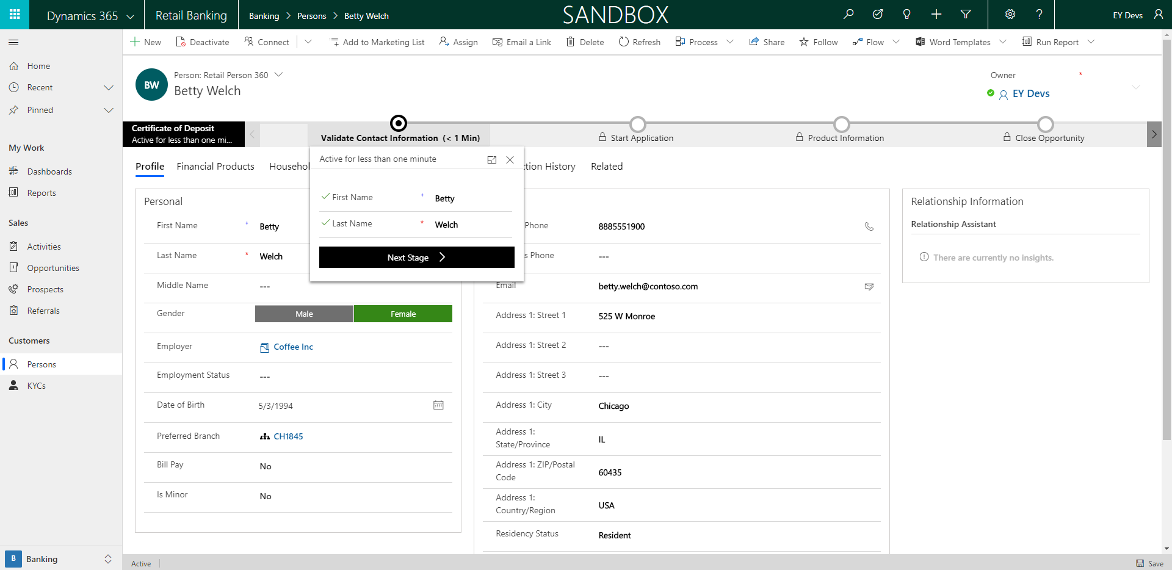

1. When creating a new certificate of deposit, the Loan Officer will begin by checking the contact information and validating it with the Person purchasing one. If the opportunity has been created by qualifying a prospect, then you can choose it from the drop down when clicking Next Stage.
   1. If the opportunity has not been created yet, click the “+New” button and a form will appear to enter in high level opportunity information.

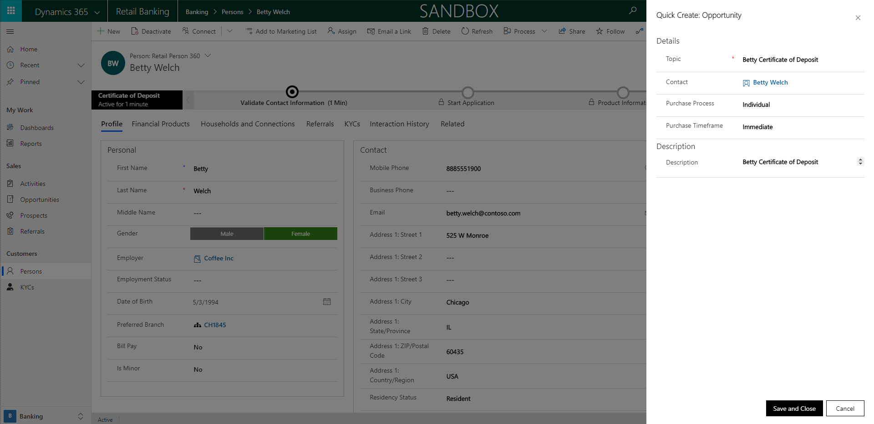

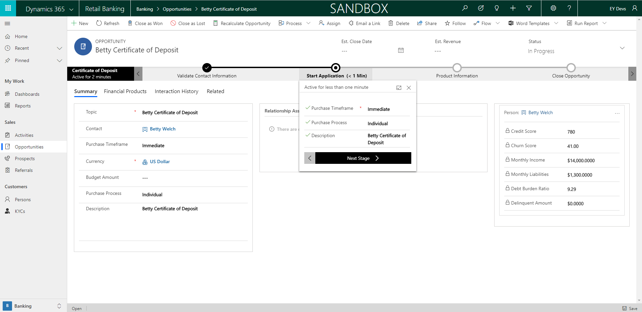

1. Saving the opportunity will take you to the next stage where you will start the application. The information will carry over and after verifying, you can move on to the product information.

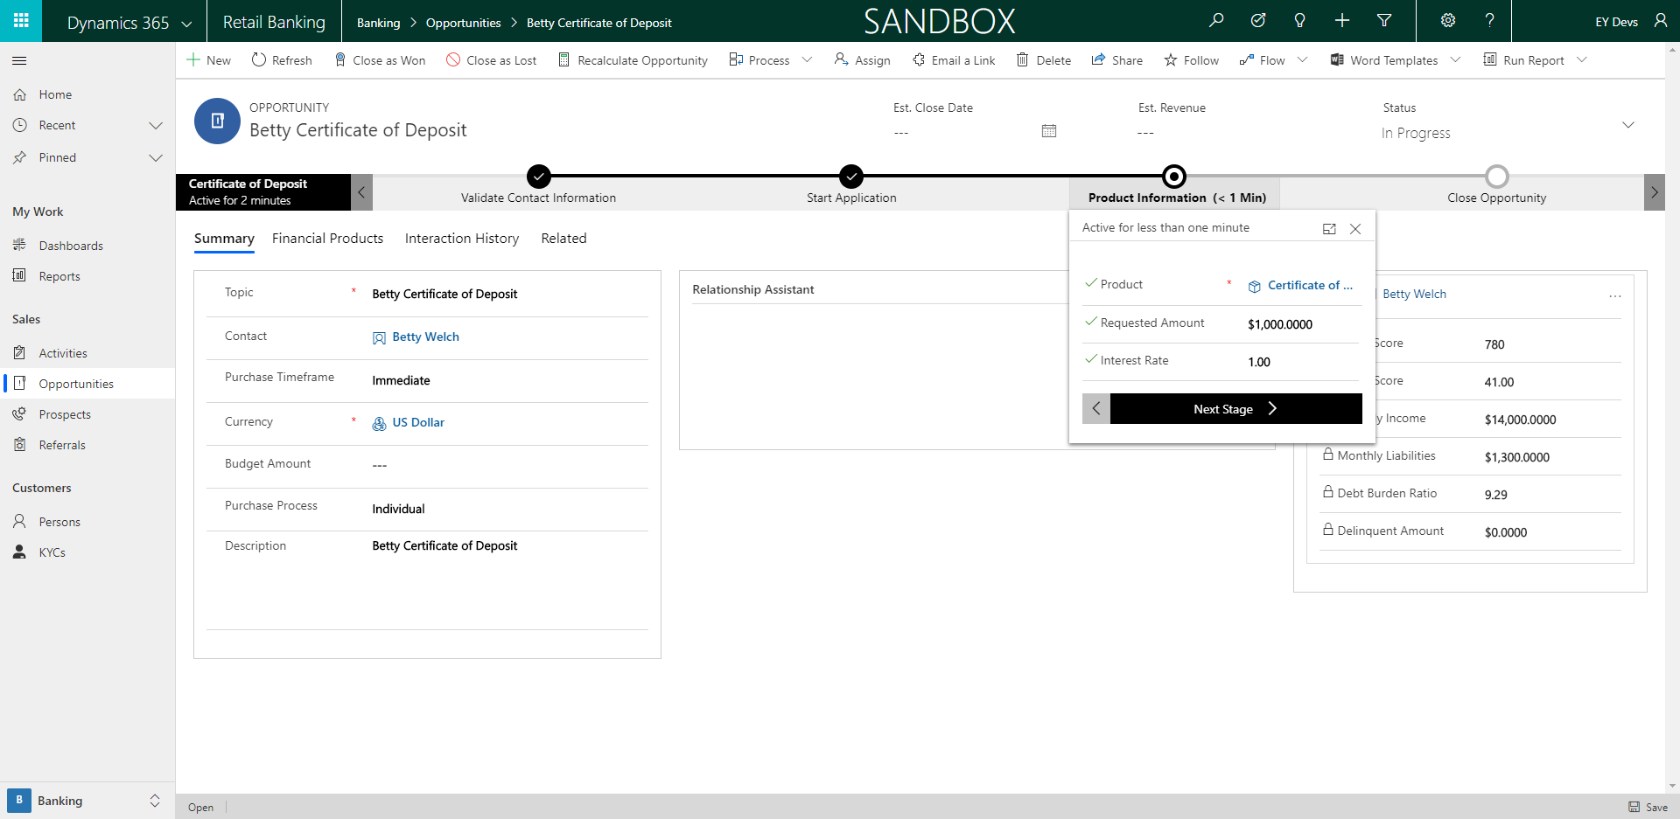

1. The next step in the flow is used to gather product information. This is going to be where the bulk of the loan information is entered or reviewed. This includes adding the Product, requested amount, and interest rate.

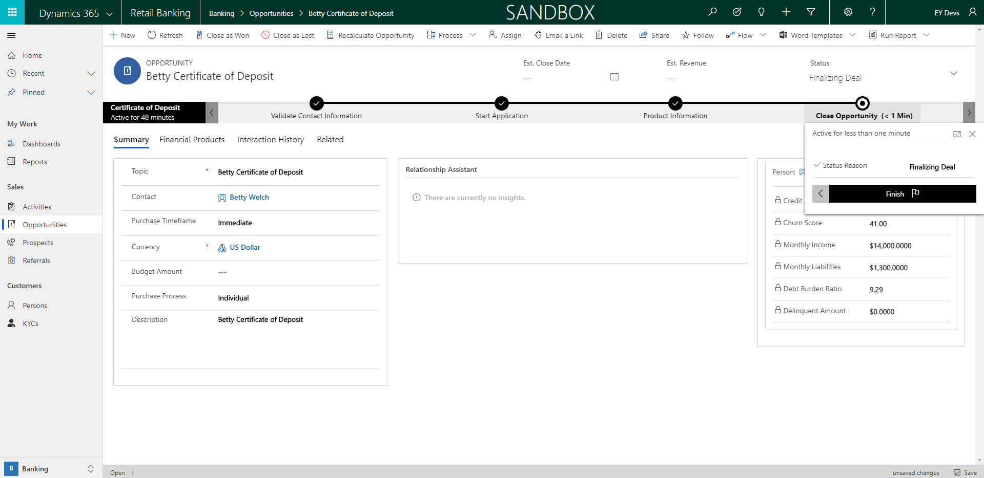

1. The last step in the application process is closing the opportunity. From here we finish the business process flow, set the status reason to finalizing deal, and close the opportunity as either won or lost. If Won, you can create a financial product of a certificate of deposit for the customer.

# Commercial

## Commercial Daily Start

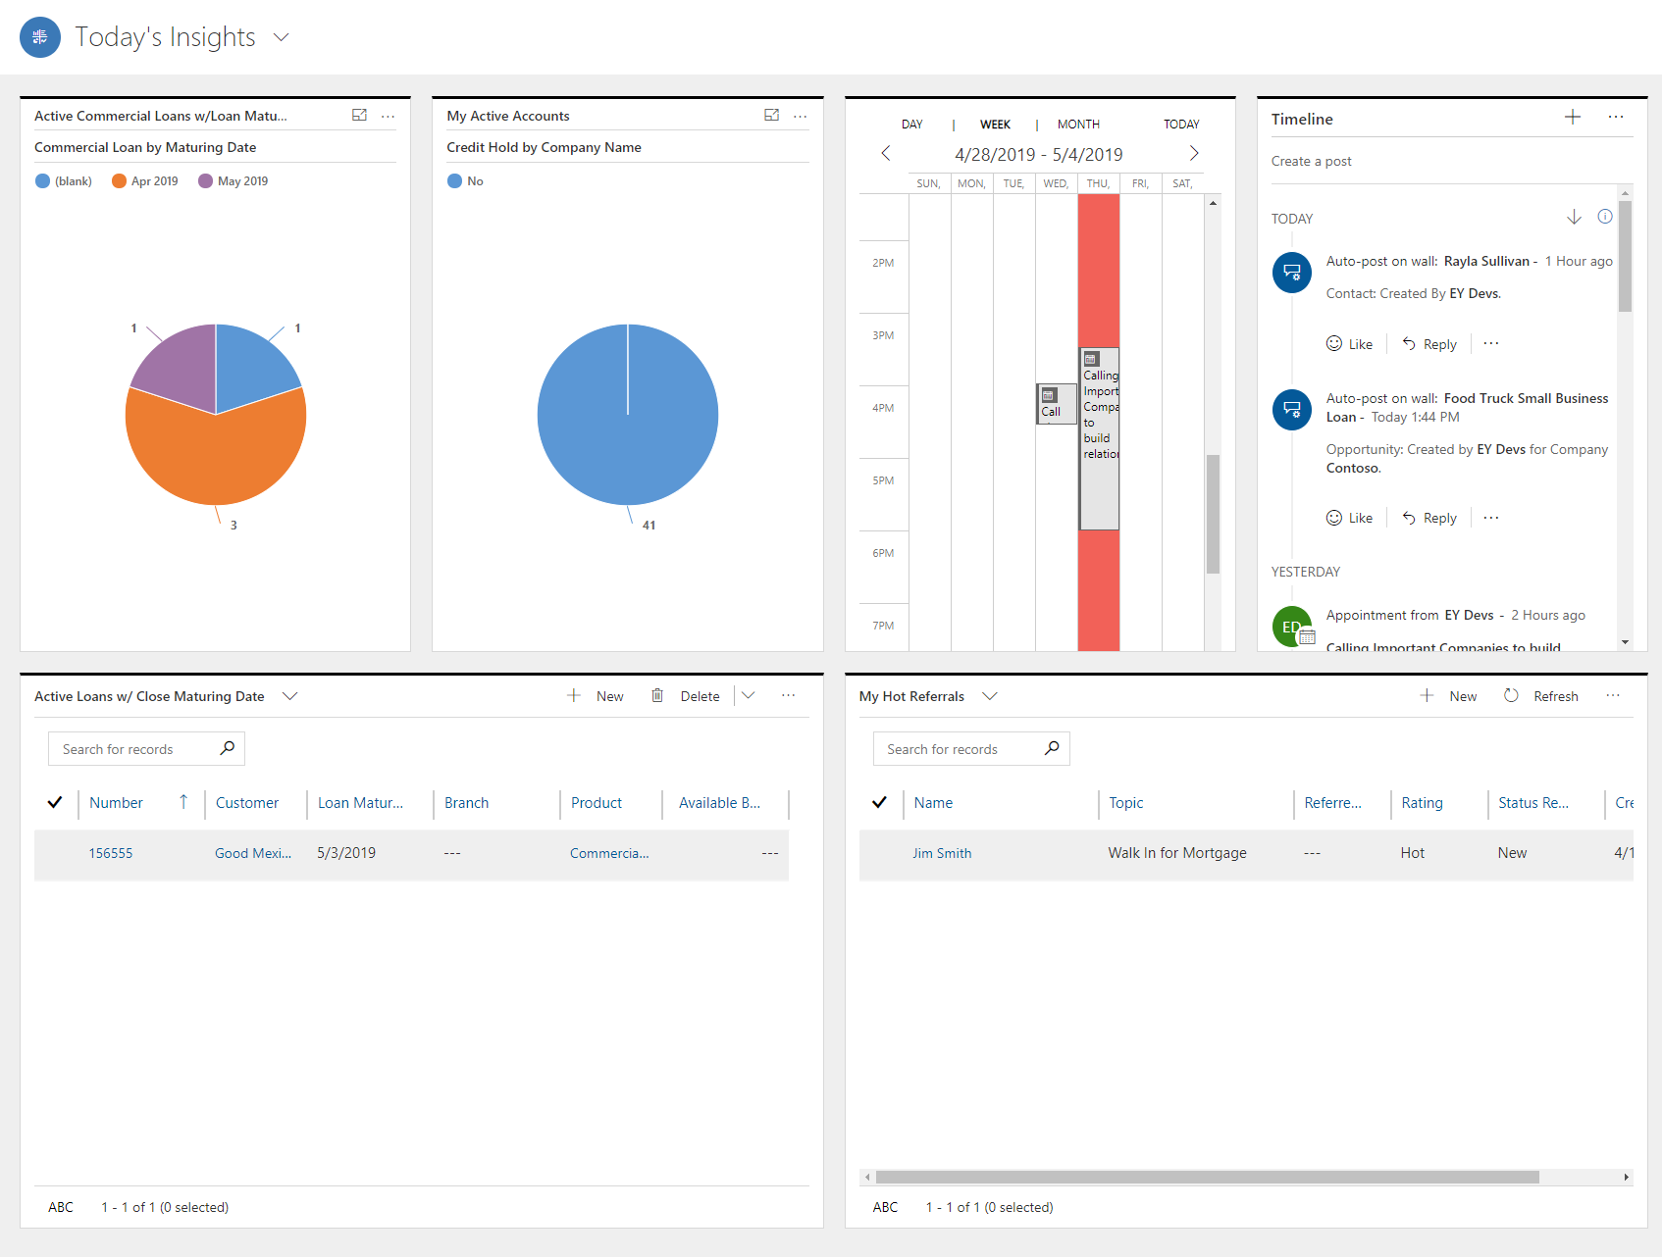

On the Today’s Insights Dashboard, a Relationship Manager would use this to get a view at their Companies and loans they have active. In the top row they will be able to see any Active Companies they are working with on a day to day. To the right of that they would look over and see their Timeline that lists out their various actives they have scheduled. On the bottom row, they can see a chart that lists their Top 5 companies with name and estimated revenue. Next, they’d be able to look and see any companies they’re working with that have active holds on their accounts. Lastly, they can see a list of any loans close to maturing.

## Applying for a New Loan

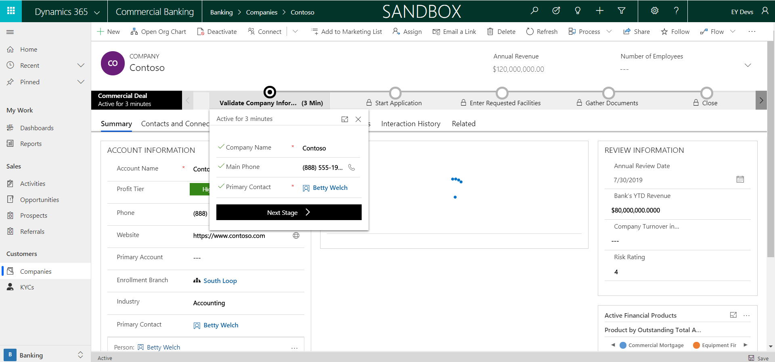

1. Applying for a new commercial loan starts on the Company record. The Loan officer will come here and begin by checking the Company Name, Primary Contact and the Main Phone for the Company.

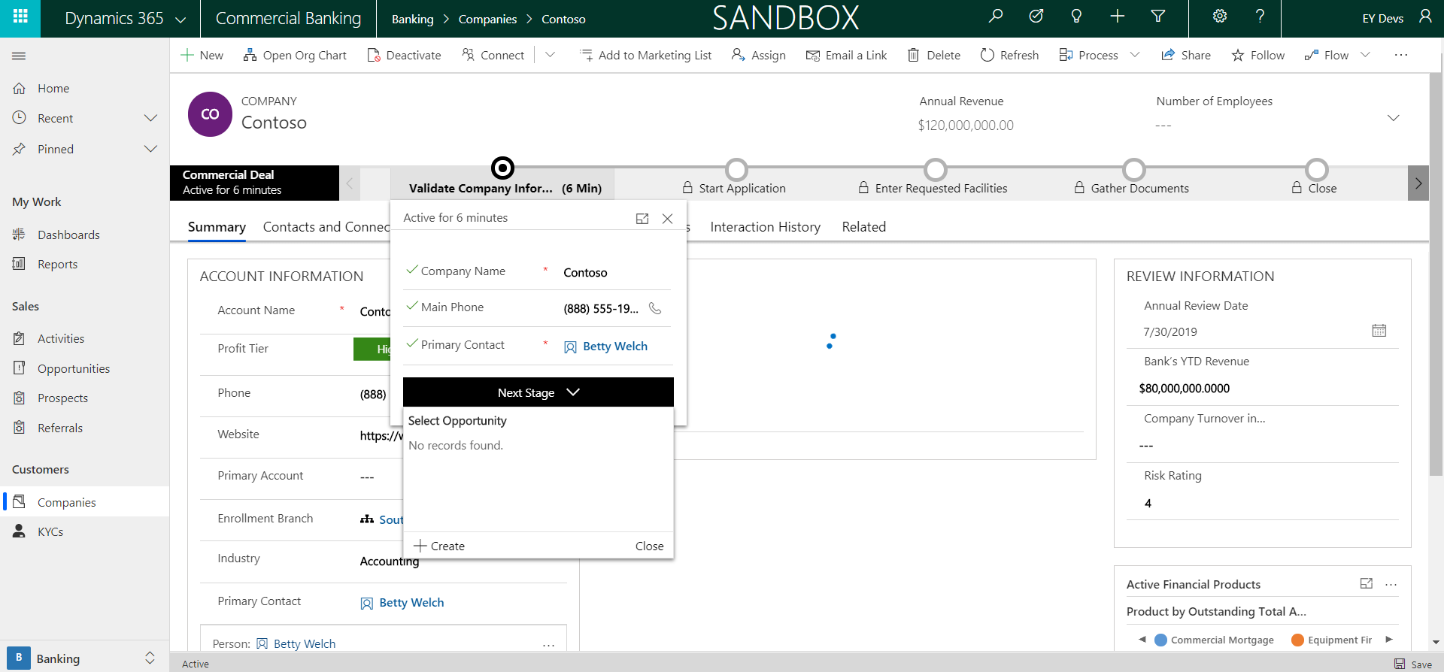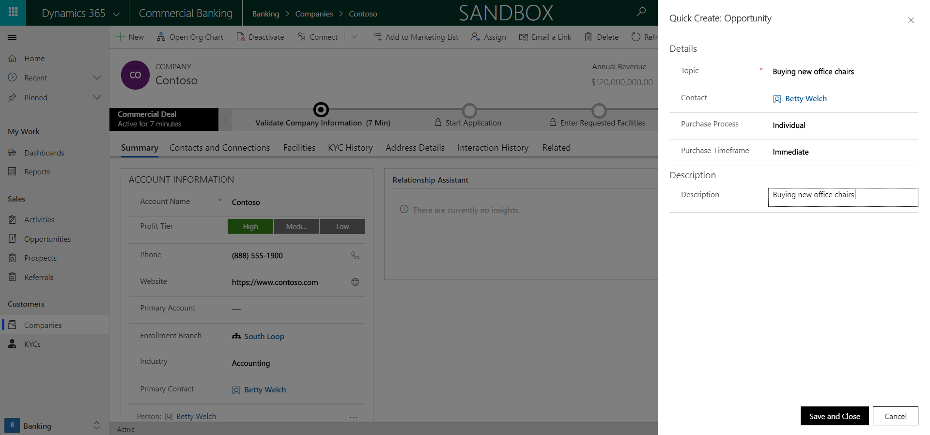

1. In the next step, we will create an Opportunity for the Commercial Loan. This will be where the Loan officer goes to add information pertaining to the application as it comes in. In the quick create, you will add high level information such as, the topic of the opportunity, the purchase timeframe, and purchase process.

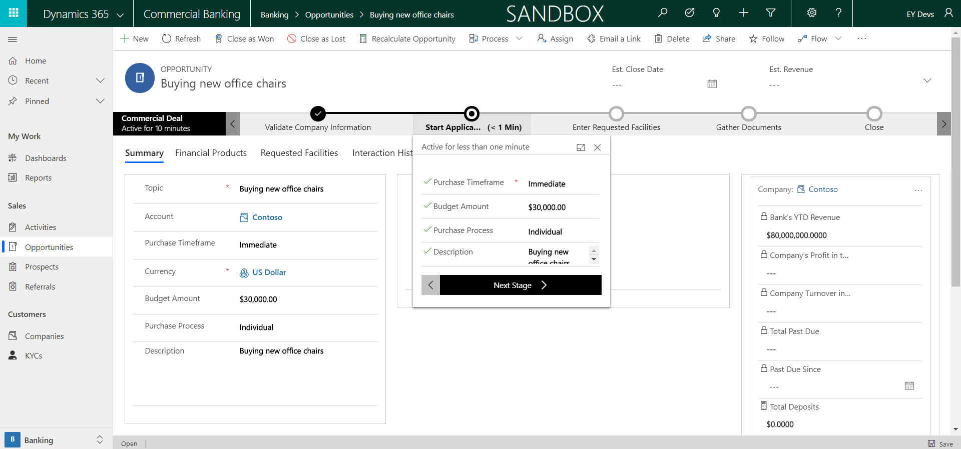

1. Saving the opportunity will take you to the next stage where you will start the application. Pieces of information will carry over, such as the process and timeframe, here you will enter the budget amount and move to the next stage.

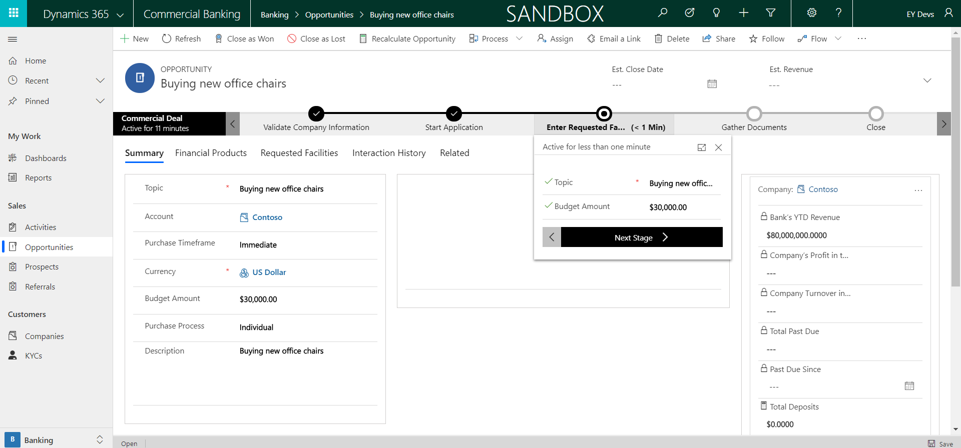

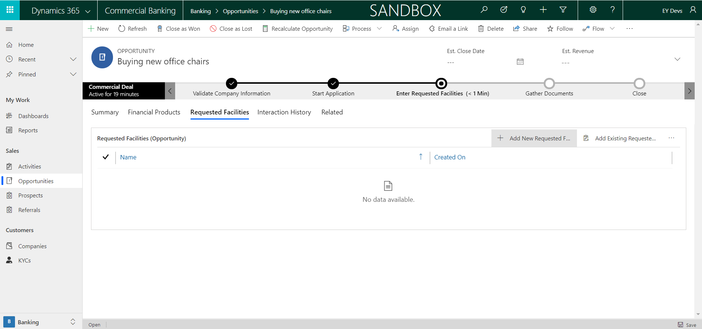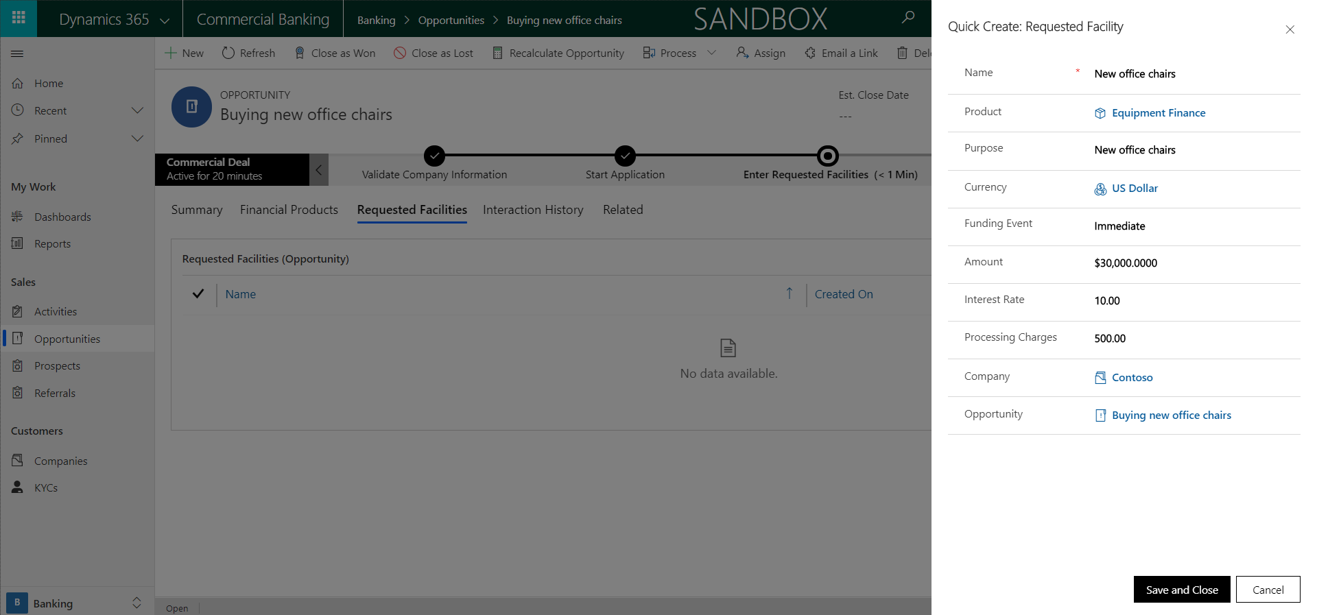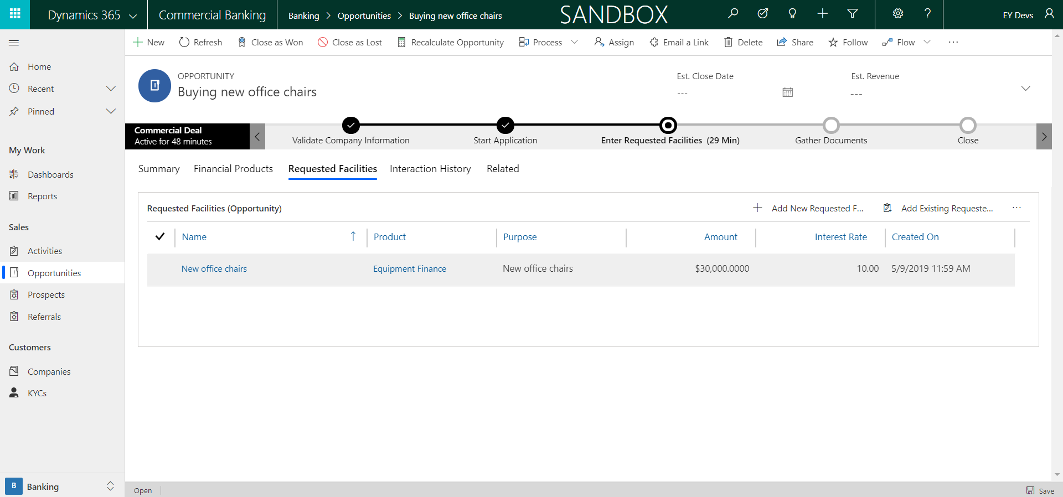

1. After starting the application, you will be taken to the Enter Requested Facilities step. This entails going and entering in as many requested Facilities as your opportunity will need. You do this by going to the Requested Facilities tab and entering them in using

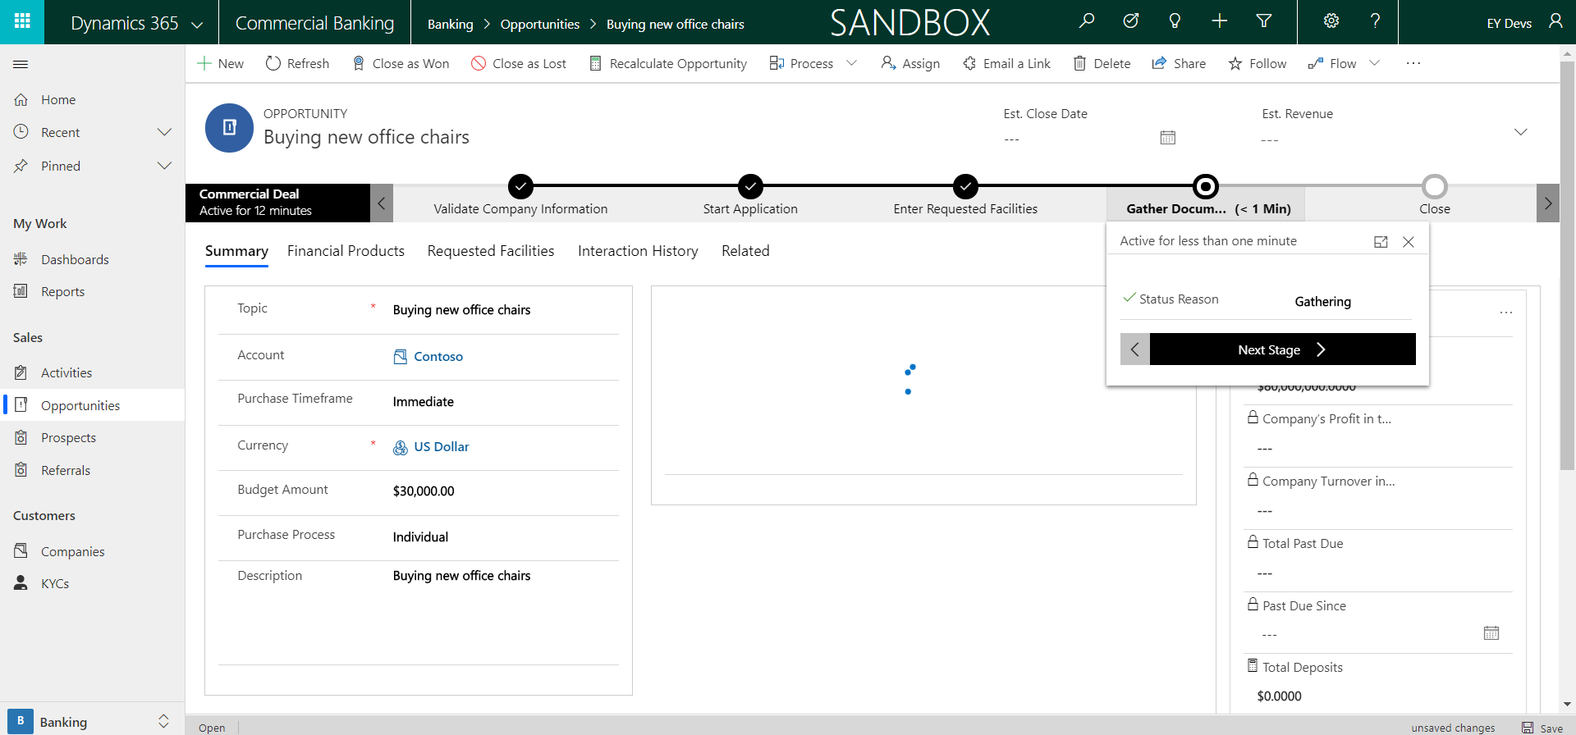

1. After creating however many requested facilities are needed, you will go into the Gathering Documents stage. You will change the Status Reason field to Gathering Documents and move forward when this step is done outside of the system.

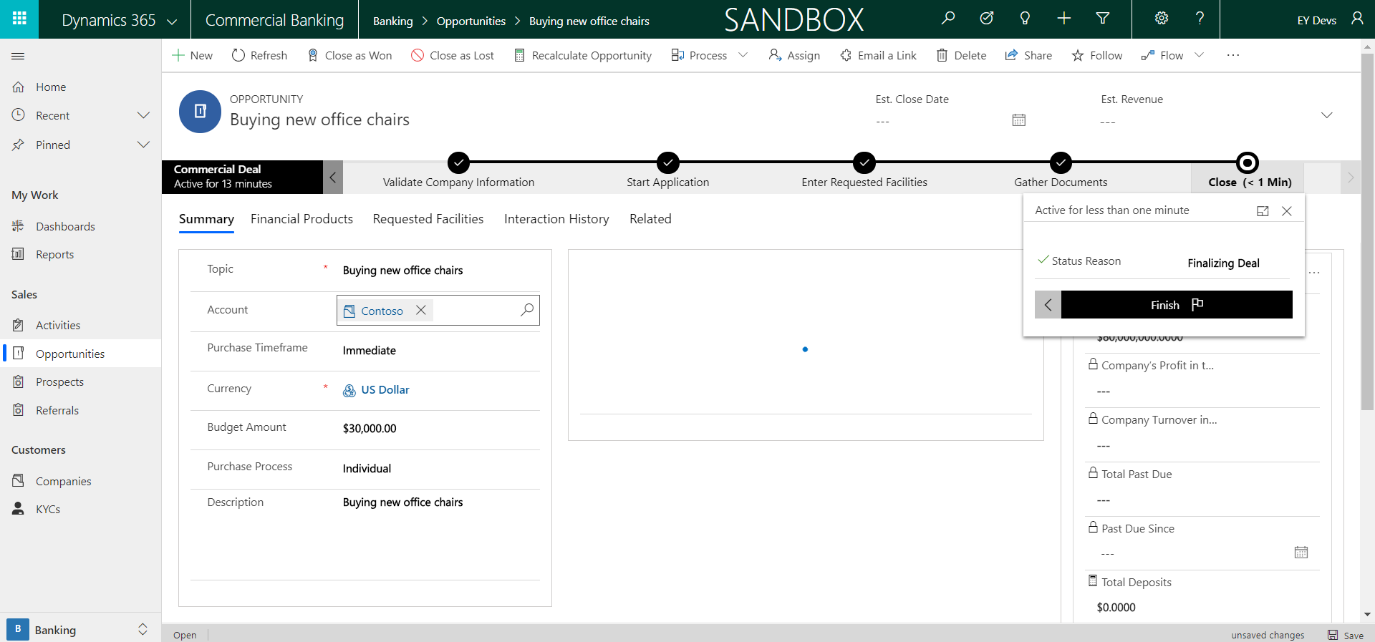

1. After you have collected all required documentation, you can finish the business process flow, and either close the Opportunity as Won or Lost. Change the status reason to Finalizing Deal and if Won, the requested facilities will be turned into financial product for this commercial loan.

## Business Checking Account

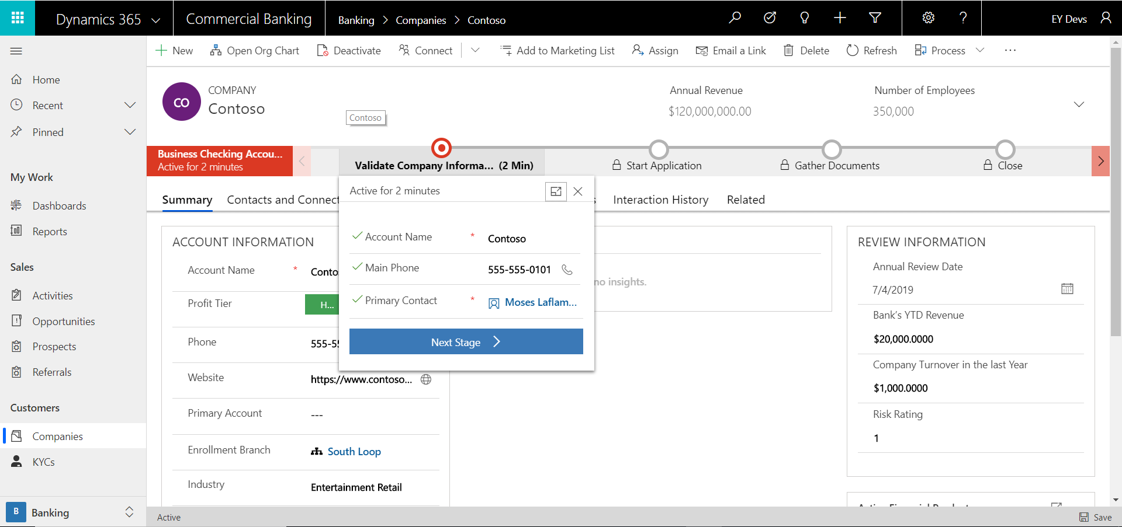

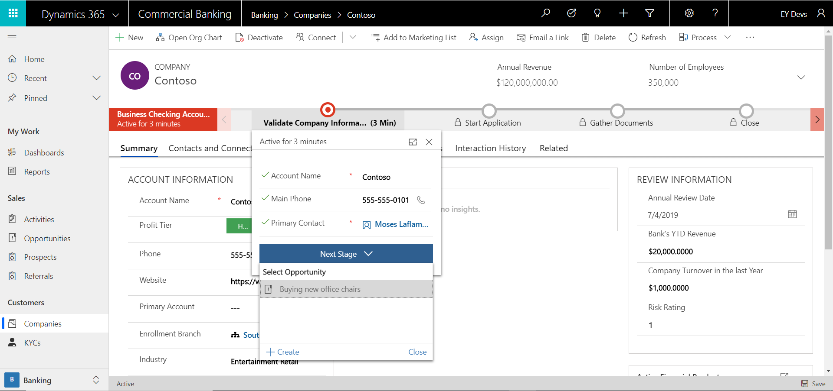

1. When creating a new Business Checking Account, the Relationship Manager will begin by checking the account information and validating it with the person applying for one. If the opportunity has been created by qualifying a prospect, then you can choose it from the drop down when clicking Next Stage.
   1. If the opportunity has not been created yet, click the “+New” button and a form will appear to enter in high level opportunity information.

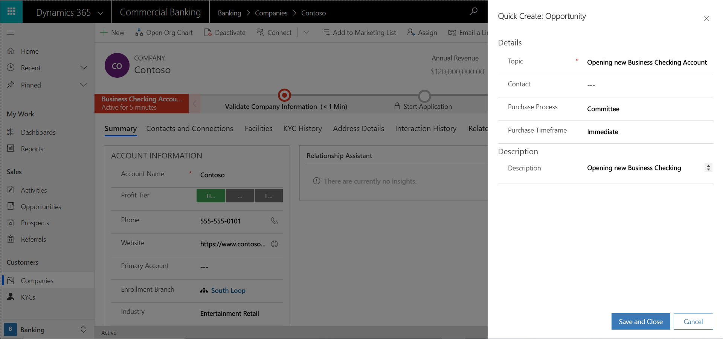

1. In the next step, we will create an Opportunity for the checking account. This will be where the relationship manager goes to add information pertaining to the application as it comes in. In the quick create, you will add high level information such as, the topic of the opportunity, the purchase timeframe, and purchase process.

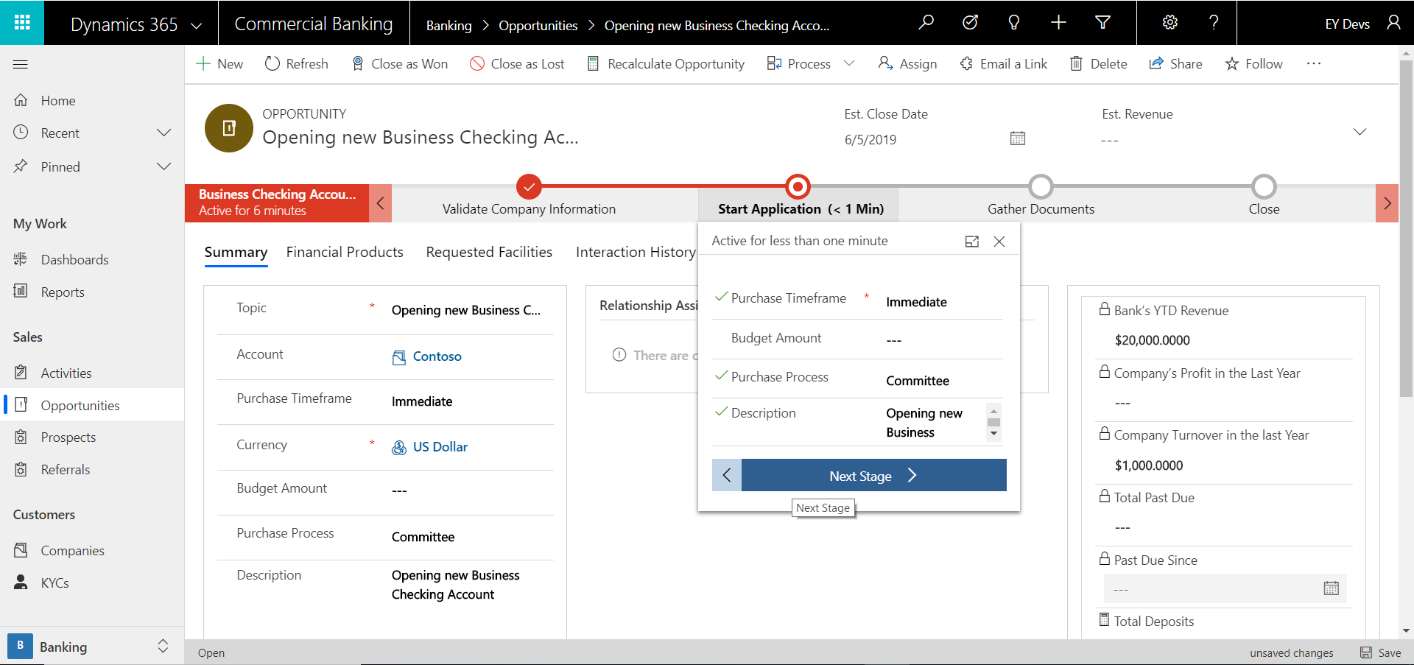

1. After hitting save and close, the manager will be taken to the Start Application stage. Here the manager will check all the appropriate information and make sure everything looks ok.

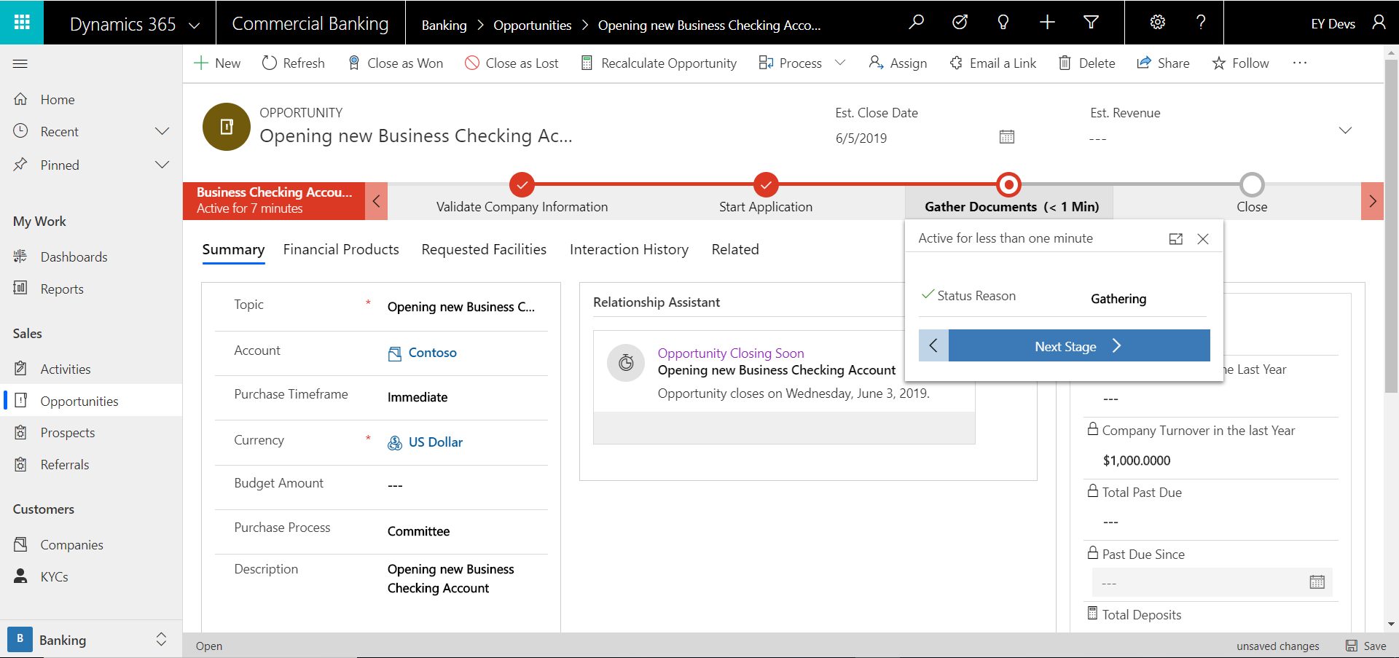

1. Hitting next stage will take the manager to the gather documents stage. Here the manager will gather the documents required to open a checking account. Changing the Status Reason to Gathering Documents will help with any metrics being measured on checking account applications the bank does.

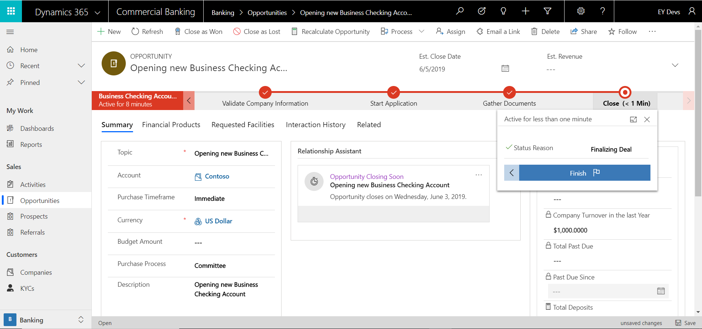

1. After gathering all the appropriate documents, the manager can then change the Status Reason to Finalizing the deal, and either close the opportunity as won or lost. If Won, the Company will be given a Business Checking Account with the bank as a Financial Product.